
NSA, Etc. ~ Surveillance Hell ~ How Bad Is It?
The answer is . . . you haven't a CLUE as to how BAD it REALLY is. If you take the time to read this article you will begin to understand how bad it is and what your future life will be like, if 'they' are able to continue to surveil us at will.
This article is the third and final part of a trilogy about the NSA (National Security Agency) and others. This article will reveal the breadth and depth of their deception, spying and control. It covers spying, both mentally and physically, AND the use of resources such as water, electricity, and land. That is not to mention the cost in dollars and loss of privacy that comes with 'their' Orwellian surveillance procedures. The FIRST TWO of the NSA, Etc., trilogy were:
1. The Tower of Babel Rises Again ~ It's Called the Utah Data Center (5-2-13)
http://www.fourwinds10.net/siterun_data/government/homeland_security_patriot_act_fema/news.php?q=1367593659
2. Secret FISA Court Deems the Constitution Irrelevant - Welcome To Surveillance Hell (6-29-13)
http://www.fourwinds10.net/siterun_data/government/new_world_order/news.php?q=1372516393
—————————————————————————————————————————————
A word of warning . . . ALL SOCIAL MEDIA IS HEAVILY MONITORED by the NSA. So, if you post there, be warned! I personally NEVER use ANY social media. Why do you think you have to ID yourself to post or read there? So they will be able to connect you to any of the very personal content you post . . . Gotcha!
Facebook has been secretly compiling 'shadow profiles' of all users
http://www.naturalnews.com/041040_Facebook_shadow_profiles_internet_privacy.html (7-2-13)
Americans agree: Facebook can't be trusted - join Diaspora for social media that gives you control
http://www.naturalnews.com/047846_Facebook_Diaspora_online_privacy.html (12-2-14)
When a Facebook user updates their status, comments on a post, or sends a message, they are creating open content that can be leveraged by advertisers, analyzed by researchers, or scrutinized by law enforcement. Nothing on Facebook is private, no matter how a person sets their "privacy settings." When Facebook unveiled a social experiment on 700,000 of its users a year ago, it became clear that the social media site can no longer be trusted.
In a new Pew Research Center privacy poll, researchers looked at the reasons why people continue to use Facebook even when they are being manipulated, extracted from, and spied upon. The research found out that the majority of Facebook users simply don't care about the information they give up. Most people are completely apathetic and do not respect their own privacy.
User's would rather bare their soul in text and share that with anyone and everyone than even consider how this affects their own privacy. In fact, Pew research found out that only half of user's think that information about their physical location over time is "very sensitive" information. Only 52 percent consider the content of their email messages "very sensitive."
Over 75 percent of users report they don't consider information regarding purchasing habits, religious views, or search engine history as "very sensitive." The only information the majority deemed "very sensitive" was social security numbers.

—————————————————————————————————————————————
Google, Facebook, others accepted millions from NSA to turn over spy data on its users
http://www.naturalnews.com/041795_technology_companies_NSA_spy_data.html (8-27-13)
As bad as it is that the National Security Agency has been caught red-handed spying wholesale on American citizens' private electronic communications, it is even worse knowing that American taxpayers paid for the "privilege" of having their Fourth Amendment rights shredded.
According to Britain's Guardian, the very newspaper that broke the NSA spy scandal and whose reporter, Glenn Greenwald, should be awarded multiple Pulitzers, Internet giants Google, Yahoo!, Microsoft and Facebook, among others, were paid millions of dollars by NSA to cover compliance costs associated with implementing the agency's vaunted "Prism" spy program - even after a federal court ruled the spying unconstitutional.
Sad but TRUE . . .
—————————————————————————————————————————————

NSA ~ The Elephant In The Room
—————————————————————————————————————————————
What the NSA is doing is 'beyond the pale', not to mention completely unconstitutional. So . . . you can just sit back and let them continue doing what they're doing, or you can work to fight against them, while there is still a chance you CAN fight back and eventually win back your freedom from their spying and control.
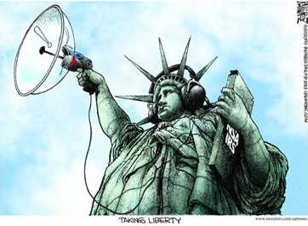
—————————————————————————————————————————————
How the NSA is still harvesting your online data
http://www.theguardian.com/world/2013/jun/27/nsa-online-metadata-collection (6-27-13)
Files show a vast scale of current NSA metadata programs . . . with one stream alone celebrating 'one trillion records processed'.
—————————————————————————————————————————————
NSA collected US email records in bulk for more than two years under Obama
http://www.fourwinds10.net/siterun_data/government/homeland_security_patriot_act_fema/news.php?q=1372784123 (6-27-13)
—————————————————————————————————————————————
Microsoft Helped the NSA Get Around Its Encryption Systems
http://www.fourwinds10.net/siterun_data/business/corporate_fraud/news.php?q=1373893674 (7-14-13)
—————————————————————————————————————————————
Uncontrolled by FISA Court 'NSA commits thousands of privacy violations per year'
http://rt.com/usa/nsa-thousands-privacy-violations-report-553/ (6-16-13)
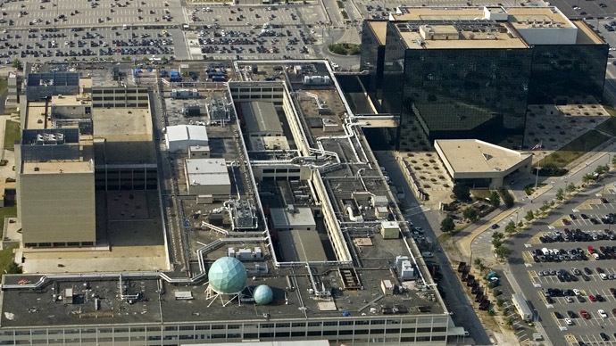
The National Security Agency (NSA) (AFP Photo//Paul J. Richards/Files)

—————————————————————————————————————————————
Shipping companies largely silent on NSA intercepting packages (12-31-13)
http://dailycaller.com/2013/12/31/shipping-companies-largely-silent-on-nsa-intercepting-packages/#ixzz2p4wciGbs (12-31-13)
—————————————————————————————————————————————
7 Things You Need To Know About The NSA: What is the NSA doing, and to whom? http://www.policestateusa.com/2013/7-things-you-need-to-know-about-the-nsa/ (9-1-13)
—————————————————————————————————————————————
Inside TAO: Documents Reveal Top NSA Hacking Unit
http://www.spiegel.de/international/world/the-nsa-uses-powerful-toolbox-in-effort-to-spy-on-global-networks-a-940969.html (12-29-13)
The NSA's TAO hacking unit is considered to be the intelligence agency's top secret weapon. It maintains its own covert network, infiltrates computers around the world and even intercepts shipping deliveries to plant back doors in electronics ordered by those it is targeting.
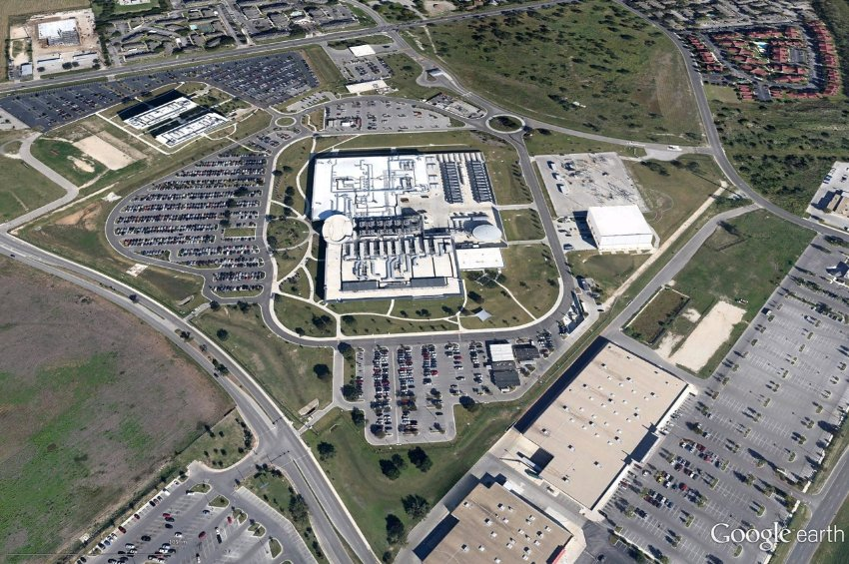
This National Security Agency complex in San Antonio, Texas, located in a former Sony chip factory, is one of the central offices of the intelligence agency's Tailored Access Operations, the NSA's top operative unit. It's something like a squad of plumbers that can be called in when normal access to a target is blocked.

—————————————————————————————————————————————
U.S. Postal Service 'Mail Imaging' Program used for Law Enforcement, Surveillance http://www.blacklistednews.com/U.S._Postal_Service_%E2%80%98mail_imaging%E2%80%99_program_used_for_law_enforcement%2C_surveillance/39405/0/38/38/Y/M.html (11-24-14)
—————————————————————————————————————————————
Postal Service Photographs Every Piece of Mail in the U.S., Shares With Agencies That Request It http://www.newsweek.com/postal-service-photographs-every-piece-mail-us-shares-agencies-request-it-280614 (10-28-14)
—————————————————————————————————————————————
Report Reveals Wider Tracking of Mail in U.S. http://www.nytimes.com/2014/10/28/us/us-secretly-monitoring-mail-of-thousands.html (11-27-14)
—————————————————————————————————————————————
Does the NSA Have a Facility in Your State? You May Be Surprised
http://benswann.com/does-the-nsa-have-a-facility-in-your-state-you-may-be-surprised/ (1-20-14)

The National Security Agency (NSA) has a global spy network which is far more expansive than many realize. With the help of the Tenth Amendment Center, a national think-tank, many states are fighting back with state level legislation that cut the NSA off from state resources.
The idea behind the legislation is that, if enacted, states will be able to keep the NSA from commandeering state resources. This will force NSA facilities to look for other locations, making it far more difficult to operate.
As of now, here is a list of geographical locations:
1.) Utah Data Center, Bluffdale, Utah
This location is the NSA’s main hub. The center stands at more than one million square feet, this $2 billion digital storage facility outside Salt Lake City is the centerpiece of the NSA’s cloud-based data strategy and essential in its plans for decryption of previously uncrackable documents.
2.) NSA headquarters, Fort Meade, Maryland
Analysts here will access material stored at Bluffdale to prepare reports and recommendations that are sent to policymakers. To handle the increased data load, the NSA is also building an $896 million supercomputer center here.
3.) Aerospace Data Facility, Buckley Air Force Base, Colorado
Intelligence collected from satellites, and signals from other spacecraft, as well as, overseas listening posts, is relayed to this facility outside Denver. Approximately 850 employees track these satellites, transmit target information, and download the intelligence data.
4.) NSA Georgia, Fort Gordon, Augusta, Georgia
Focuses on intercepts from Europe, the Middle East, and North Africa. Codenamed Sweet Tea, the facility has been massively expanded and now consists of a 604,000-square-foot operations building for up to 4,000 intercept operators, analysts, and other specialists.
5.) NSA Texas, Lackland Air Force Base, San Antonio
This location recently underwent a $100 million renovation. The center functions as a data backup center for the Utah center. Also, the center focuses on intercepts from Latin America and, since 9/11, the Middle East and Europe. Some 2,000 workers staff the operation.
6.) Multiprogram Research Facility, Oak Ridge, Tennessee
Approximately 300 scientists and computer engineers with top security clearance spend their day here. They are currently tasked with building the fastest quantum supercomputers in the world and working on cryptanalytic applications and other secret projects which are unknown to the public.
7.) NSA Hawaii, Oahu
This center intercepts data from Asia. The center was built to house an aircraft assembly plant during World War II, the 250,000-square-foot bunker is nicknamed the Hole. Its 2,700 employees now do their work above-ground from a new 234,000-square-foot facility.
The NSA also controls four satellites and has multiple international data [spying] centers. Many are wondering what the solution is. As mentioned before, the Tenth Amendment Center has provided one.
—————————————————————————————————————————————

This Is The NSA's 'Main Hub' in Bluffdale, Utah
—————————————————————————————————————————————
NSA's own website found here: https://nsa.gov1.info/utah-data-center/ where they lie and say: "Openness and Transparency: Our Cooperation with Privacy Groups" ha, ha, ha!
Check out what they say on the front of 'their' building:
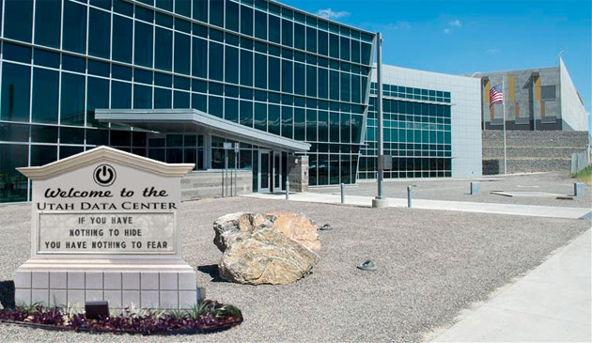
Utah Data Center Administration Building
I'm curious to discover what the 'corner stone' says on it? Anyone know? I'm betting on Freemasonry symbols.

—————————————————————————————————————————————
http://www.businessinsider.com/prism-is-just-the-start-of-nsa-spying-2013-6
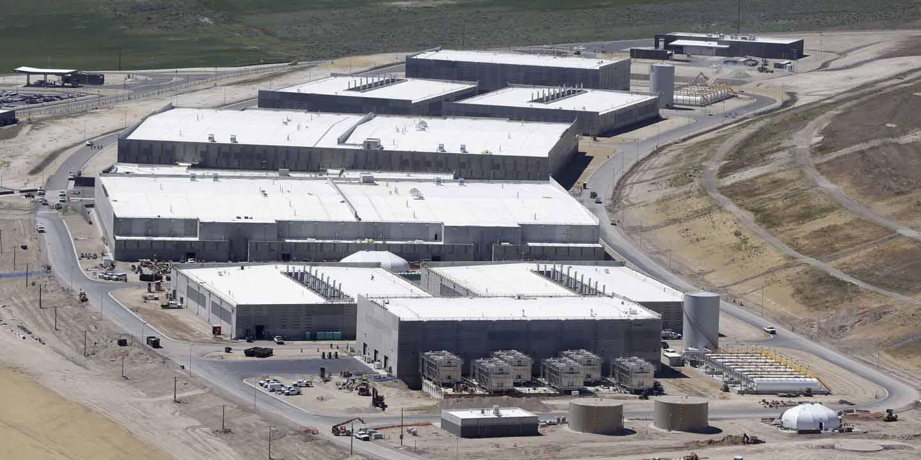
AP/Rick Bowmer
The NSA's Utah Data Center, where the NSA will store zettabytes of global Internet traffic.nsa
—————————————————————————————————————————————
https://en.wikipedia.org/wiki/Utah_Data_Center
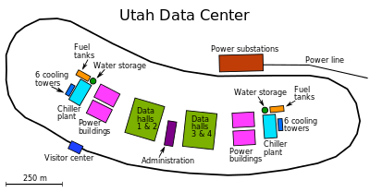
The Utah Data Center area layout.
—————————————————————————————————————————————
What's the significance of NSA's latest 1 million square foot Bluffdale, Utah mega-facility? Read on . . .

—————————————————————————————————————————————
About Posse Comitatus and Habeas Corpus ~ Your Rights ERASED!
—————————————————————————————————————————————

When we begin to fight back . . . the following history lesson is relevant. Please remember that posse comitatus, the required separation of the military and the police no longer exists. Nor does your Constitutional right to habeas corpus, which allows you to seek legal or judicial relief from UNLAWFUL imprisonment.
Where did they go?
In 2006, I wrote an article titled: Two 'Acts' of Tyranny On The Same Day! found here: http://www.stopthenorthamericanunion.com/TwoActsOfTyranny.html
Although there have been claims that habeas corpus and posse comitatus have only recently been taken away . . . they're wrong. They both disappeared in 2006 (eight years ago). The following information came from that article:
On October 17, 2006, 'a date which will live in infamy' . . . there were two acts of tyranny committed. The first was a public signing of the 'Military Commissions Act of 2006' which suspended habeas corpus allowing the president to declare you an 'enemy combatant' and end your rights to seek legal or judicial relief from unlawful imprisonment.
The second act of tyranny took place in a private Oval Office ceremony, in which the president signed into law the 'John Warner National Defense Authorization Act (NDAA) of 2007' which essentially eliminates the protections of the Posse Comitatus Act and re-wrote the Insurrection Act. The NDAA will allow the president to declare a 'public emergency' and take control of state-based National Guard units without the consent of the governor or local authorities, in order to 'suppress public disorder'!
The following video demonstrates just how 'they' removed our constitutional right to habeas corpus . . . all it takes is a corrupt, TREASONOUS attorney general as evidenced here:

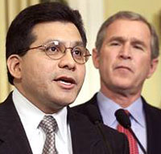
Gonzales: ‘There Is No Express Grant of Habeas Corpus In The Constitution’
Yesterday, [1/18/07] during Senate Judiciary Committee hearings, Attorney General Alberto Gonzales . . . was debating Sen. Arlen Specter (R-PA) about whether the Supreme Court’s ruling on Guantanamo detainees last year cited the constitutional right to habeas corpus. Gonzales claimed the Court did not cite such a right, [Specter disagreed] then [Gonzales] added, “There is no express grant of habeas in the Constitution.”
Specter pushed back. “Wait a minute. The constitution says you can’t take it away, except in the case of rebellion or invasion. Doesn’t that mean you have the right of habeas corpus, unless there is an invasion or rebellion?”
You MUST watch this EXTREMELY DISGUSTING video featuring crypto-fascist Gonzales:
https://www.youtube.com/watch?feature=player_embedded&v=YIFqYVAOosM (2:28)

—————————————————————————————————————————————

Posse Comitatus - Used To Separate the Military From The Police
—————————————————————————————————————————————
Today we have the obverse. Now we have 'fusion centers' that COMBINE the military and police. In addition the local police are being given 'surplus' military vehicles to use. Do you fully understand where we are going?
In 2007,I wrote another article titled: The EU and the NAU ~ Two Peas In A Pod found here: http://www.stopthenorthamericanunion.com/TwoPeas.html The following information appears in that article:
The Escalating Role of the Military . . .
"The Pentagon, as one might expect, plays an even more direct role in martial law operations. Title XIV of the new law, entitled, Homeland Defense Technology Transfer Legislative Provisions, authorizes the Secretary of Defense to create a Homeland Defense Technology Transfer Consortium to improve the effectiveness of the Department of Defense (DOD) processes for identifying and deploying relevant DOD technology to federal, State, and local first responders.”
"In other words, the law facilitates the 'transfer' of the newest in so-called 'crowd control' technology and other weaponry designed to suppress dissent from the Pentagon to local militarized police units. The new law builds on and further codifies earlier “technology transfer” agreements, specifically the 1995 DOD-Justice Department memorandum of agreement achieved back during the Clinton-Reno regime."
As The Military Becomes The Police ~ The SWAT Police Become The Military . . .
"The historic and ominous re-writing of the Insurrection Act, accomplished in the dead of night, which gives Bush [or any other president] the legal authority to declare martial law, is now an accomplished fact."
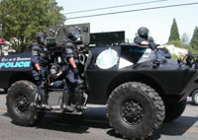
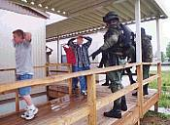
"The Pentagon, as one might expect, plays an even more direct role in martial law operations. Title XIV of the new law, entitled, Homeland Defense Technology Transfer Legislative Provisions, authorizes the Secretary of Defense to create a Homeland Defense Technology Transfer Consortium to improve the effectiveness of the Department of Defense (DOD) processes for identifying and deploying relevant DOD technology to federal, State, and local first responders.
—————————————————————————————————————————————
Still Think It's NOT a Police State?
—————————————————————————————————————————————
Then watch this video of a lone woman in a skirt and heels (2:35), who is wearing a red jacket and carrying a sign that says 'Fear Totalitarianism' as she is maliciously shot in the back and leg with rubber bullets by some members of the SWAT (Special Weapons And Tactics) 'para-military' police as they apply excessive and unwarranted force.
Then as she crouches down behind her sign they shoot her again in the head, just above her eyes. Watch as the commander of the police laughs and jokes with the men about shooting her in the head, as if it is some kind of macho joke.
She was protesting the use of excessive force during a free trade protest. Catch the irony there? What has happened to those who once were to 'protect and defend' We the People? Encouraged by our federal government, they have turned on us with a police state mentality. Shameful and terrifying . . . right here in America.
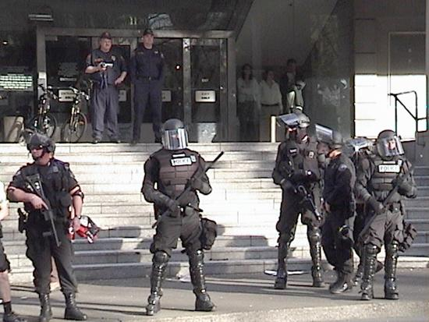
Their 'toys' . . .

FBI Informs Local Police To Watch Out For 'Defenders' of US Constitution:
FBI Brochures, printed at taxpayer expense to inform law enforcement how to define when the 'Joint Terrorism Task Force' is to be notified. For example: "Groups or individuals operating entirely inside the US, attempting to influence the US government or population to effect political or social change by engaging in criminal activity'." Where criminal activity is listed as being: "Right-Wing Extremists [who are] 'defenders' of US Constitution against federal government and the UN (Super Patriots) - Groups of individuals engaged in para-military training . . . Hate Groups: [such as] Christian Identity and White Nationalists."
How does one 'defend' the Constitution AGAINST the federal government when THEY are sworn to 'protect and defend' that same Constitution? Isn't that an oxymoron?
Does the 'para-military training' include Constitutionally permitted militias? It doesn't say. 'White Nationalists' what does that mean, anybody who is white and believes in national sovereignty? 'Christian Identity' . . . does that mean anybody that identifies themselves as a Christian? Of course, 'to those in the know' they are VERY specific targets and involve thousands and thousands of people like you and me.
You can continue reading here: http://www.stopthenorthamericanunion.com/TwoPeas.html

—————————————————————————————————————————————

'Heart Stopping' Constitutional TREASON By CIA Director Hayden
—————————————————————————————————————————————

In a question and answer session . . . "Jonathan Landay with Knight Ridder [said]: I'd like to stay on the same issue, and that had to do with the standard by which you use to target your wiretaps. I'm no lawyer, but my understanding is that the Fourth Amendment of the Constitution specifies that you must have probable cause to be able to do a search that does not violate an American's right against unlawful searches and seizures . . . The legal standard is probable cause, General. ... I'd like you to respond to this -- is that what you've actually done is crafted a detour around the FISA court by creating a new standard of "reasonably believe" in place [of] probable cause because the FISA court will not give you a warrant based on reasonable belief, you have to show probable cause. Could you respond to that, please?"
Hayden: "Sure. I didn't craft the authorization. I am responding to a lawful order. All right? [whose order?] The attorney general has averred to the lawfulness of the order. Just to be very clear -- and believe me, if there's any amendment to the Constitution that employees of the National Security Agency are familiar with, it's the Fourth. And it is a reasonableness standard in the Fourth Amendment. And so what you've raised to me -- and I'm not a lawyer, and don't want to become one -- what you've raised to me is, in terms of quoting the Fourth Amendment, is an issue of the Constitution. The constitutional standard is "reasonable." And we believe -- I am convinced that we are lawful because what it is we're doing is reasonable."
The Fourth Amendment of the Constitution:
"The right of the people to be secure in their persons, houses, papers, and effects, against unreasonable searches and seizures, shall not be violated, and no Warrants shall issue, but upon probable cause, supported by Oath or affirmation, and particularly describing the place to be searched, and the persons or things to be seized."
This however is how the NSA, CIA, FBI, etcetera . . . have twisted and perverted the 4th Amendment with help of the FISA Courts who have designated the United States as a 'foreign country' in order to completely ignore the Constitution. They have also struck from the legal language the term 'probable cause' and replace by 'reasonably believe'. That too began many years ago in 2006, when the TREASONOUS General Michael Hayden was the Director of the CIA.
Be SURE TO WATCH The Hayden video here: http://www.stopthenorthamericanunion.com/videos/HaydenConstitutionalInterpretation.html#Title
'Probable cause is a LEGAL term with SIGNIFICANT specifications about how that is to occur, NOT just somebody saying they 'reasonably believe' a crime as been committed! Once you've watched the video you will FINALLY begin to understand how the government has twisted and perverted the language of the Constitution to support the destruction our Constitutional protections. Done by the Director of the CIA no less. Wake UP America!
—————————————————————————————————————————————
Fast Forward To 9-11-2013 . . .
—————————————————————————————————————————————
Please note that my comments about the content of the
following quoted and indented articles are in PINK!

Gems Mined from the NSA Documents and FISA Court Opinions Released
http://www.fourwinds10.net/siterun_data/government/fraud/911_attack/news.php?q=1379005411
The following information DEMONSTRATES the 'REASONABLE' standard prevailed while the Constitutional requirement of 'PROBABLE CAUSE' was NOT used to define the NSA's standard of operations. The 'slippery slope' has evolved to the following:
. . . The Search for a Basis for Searching
In a March 2, 2009 FISA court opinion, the Court noted that the program collects "communication of U.S. person who are not the subject of an FBI investigation to protect against international terrorism or clandestine intelligence activities, and are data that otherwise could not be legally captured in bulk by the government." (first emphasis by the court, second ours). "Ordinarily, this alone would provide sufficient grounds for a FISC [Foreign Intelligence Surveillance Court] judge to deny the application."
The Court noted that, nevertheless, the spying was approved, based on the Court's confidence in the NSA's assurances of a good process and strict controls. By March 2009, however, "The Court no longer has such confidence." The Court's particularly scathing statement about its distrust in the NSA can be found on page 12 here: (http://www.dni.gov/files/documents/section/pub_March%202%202009%20Order%20from%20FISC.pdf)
What happened was that the FISC required the NSA have a "reasonable articulable suspicion" before conducting a search on a phone number. The NSA decided, independently, that it could run searches on the database to develop the basis for the reasonable articulable suspicion. Hence, the NSA was conducting suspicionless searches for information to obtain the court-required basis to search for that information. How clever by half is THAT??? Had 'Probable Cause' been the requirement there would have been NO way they could have gotten around the law. But . . . that's what happens when you ignore and subvert the Constitution . . . chaos reigns and thus it has allowed the NSA to run rampant!
—————————————————————————————————————————————

Obama secretly reversed NSA surveillance restriction in 2011
http://www.naturalnews.com/042161_NSA_Obama_surveillance_restrictions.html
"The FISA court's decision permitted the NSA "to query the vast majority" of its email and phone databases, using email addresses and phone numbers of Americans and legal residents - and all without a warrant . . ."
"The [follow on] inquiries have to be "reasonably likely to yield foreign intelligence information," . .
In other words, it's a strategy of spying first and protecting privacy later . . if at all.
—————————————————————————————————————————————

How Did We Arrive At The Current Massive Surveillance?
—————————————————————————————————————————————
ECHELON: Exposing the Global Surveillance System
http://www.globalresearch.ca/echelon-exposing-the-global-surveillance-system/30532 (2-1-1997)
Designed and coordinated by NSA, the ECHELON system is used to intercept ordinary e-mail, fax, telex, and telephone communications carried over the world’s telecommunications networks. Unlike many of the electronic spy systems developed during the Cold War, ECHELON is designed primarily for non-military targets: governments, organizations, businesses, and individuals in virtually every country. It potentially affects every person communicating between (and sometimes within) countries anywhere in the world.
It is, of course, not a new idea that intelligence organizations tap into e-mail and other public telecommunications networks. What was new in the material leaked by the New Zealand intelligence staff was precise information on where the spying is done, how the system works, its capabilities and shortcomings, and many details such as the codenames.
The ECHELON system is not designed to eavesdrop on a particular individual’s e-mail or fax link. Rather, the system works by indiscriminately intercepting very large quantities of communications and using computers to identify and extract messages of interest from the mass of unwanted ones. A chain of secret interception facilities has been established around the world to tap into all the major components of the international telecommunications networks. Some monitor communications satellites, others land-based communications networks, and others radio communications. ECHELON links together all these facilities, providing the US and its allies with the ability to intercept a large proportion of the communications on the planet.
—————————————————————————————————————————————
ECHELON Today: The Evolution of an NSA Black Program
http://www.globalresearch.ca/echelon-today-the-evolution-of-an-nsa-black-program/5342646 (7-13-13)

"Before PRISM there was ECHELON: the top secret surveillance program whose all-encompassing “dictionaries” (high-speed computers powered by complex algorithms) ingest and sort key words and text scooped-up by a global network of satellites, from undersea cables and land-based microwave towers."
People are shocked by the scope of secret state spying on their private communications, especially in light of documentary evidence leaked to media outlets by former NSA contractor Edward Snowden.
While the public is rightly angered by the illegal, unconstitutional nature of NSA programs which seize and store data for retrospective harvesting by intelligence and law enforcement officials, including the content of phone calls, emails, geolocational information, bank records, credit card purchases, travel itineraries, even medical records–IN SECRET, and with little in the way of effective oversight–the historical context of how, and why, this vast spying apparatus came to be is often given short shrift.
Revelations about NSA spying didn’t begin June 5, 2013 however, the day when The Guardian published a top secret FISA Court Order to Verizon, ordering the firm turn over the telephone records on millions of its customers “on an ongoing daily basis.”
—————————————————————————————————————————————
NSA Whistleblower Russ Tice Goes On Record
(THIS IS A MUST LISTEN CURRENT OUTING OF THE NSA):
http://www.youtube.com/watch?v=g1Lurd5QvZA&feature=player_embedded (1:22:46) Second source:
http://www.brasschecktv.com/videos/the-surveillance-state/the-complete-russell-ticesibel-edmonds-interview.html
In this bombshell episode of the Boiling Frogs Post Podcast Show NSA whistleblower Russ Tice joins us to go on record for the first time with new revelations and the names of official culprits involved in the NSA's illegal practices. Mr. Tice explains in detail how the National Security Agency targets, sucks-in, stores and analyzes illegally obtained content from the masses in the United States.
He contradicts officials and the mainstream media on the status of the NSA's Utah facility, which is already operating and "On-Line." He reveals the NSA as a Deep State that targets and wiretaps US political candidates for its own purposes.
We discuss the latest controversies involving the NSA, PRISM, Edward Snowden, and the spins and lies that are being floated by the US mainstream and pseudo-alternative media.
http://www.boilingfrogspost.com/2013/06/19/podcast-show-112-nsa-whistleblower-goes-on-record-reveals-new-information-names-culprits/
—————————————————————————————————————————————
The Term 'Dictionaries' Doesn't Come Close ~ How About a Yottabyte?
—————————————————————————————————————————————
To understand the depth and breadth of the planned data capture and manipulation of that data . . . you need to understand the following computer terminology:
1. The total of all human knowledge created since the dawn of man to the year 2003 totaled 5 EXABYTES and will probably reach only 966 EXABYTES per year by 2015.
2. ONE MILLION EXABYTES = ONE YOTTABYTE.
3. A SINGLE YOTTABYTE of information, is equal to roughly . . . 500 quintillion (500,000,000,000,000,000,000) pages of text.
4. The computers at the Utah Data Center will be collecting YOTTABYTES! Thus . . . out of many languages there will be . . . ONE COMPUTER LANGUAGE FOR ALL the languages ever entered!
Thus God's punishment for the 'Tower of Babel' will be reversed by the NSA!
Take in all of the above and then realize that the . . . they will be using the emergent quantum computer technology.

—————————————————————————————————————————————
Since 1997 ~ Surveillance Technology Has Made Quantum Leaps . . .
—————————————————————————————————————————————
This 'tech talk' video reveals the creation and business model for quantum computing by the D-Wave mastermind:
Quantum Journey ~ D-Wave Chief Scientist, Eric Ladizinsky
https://www.youtube.com/watch?v=fArXhQBLDWE (27:54)
—————————————————————————————————————————————
What is Quantum Computing? http://www.smallbizlabs.com/2013/05/what-is-quantum-computing.html
The announcements that Google and Lockheed Martin have purchased quantum computers has led to a lot of recent coverage on the topic. See my comments in pink:
Quantum computers are very, very fast. Instead of using the traditional approach of a string of 1's and 0's that are either turned on or off, quantum computers use quantum bits, or qubits.
Qubits take advantage of the weird behavior of quantum mechanics which means they can essentially be both on and off at the same time. This allows them to multitask and at least in some cases potentially run thousands of times faster than traditional computers. Read that again . . . It can run THOUSANDS OF TIMES FASTER than traditional computers!
The leader in quantum computing is a Canadian company called D-Wave. Their machines are not cheap to buy nor cheap to run. MIT's Technology Review reports both Lockheed Martin and Google likely paid in the $15 million range for their quantum computer.
And GigaOm has an interesting article on the expensive and difficult need to cool quantum computers to near absolute zero.
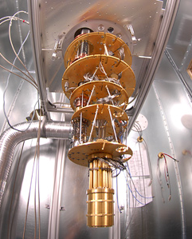
The picture on the right shows part of the D-Wave cooling tower.
So don't expect to see quantum computers at Best Buy anytime soon.
Google says they are going to focus their quantum computing efforts on machine learning applications. Why does Google need quantum computing? Think about it . . . what does Google do for a living? Do you use Google's browser, use Google's mapping? They will know what you do and where you are going . . . every step of the way!!!!!
According to a NY Times article, Google's Quantum Artificial Intelligence Lab, which is what they are calling their quantum computing entity, will focus on:
"machine learning, which is the way computers take note of patterns of information to improve their outputs. Personalized Internet search and predictions of traffic congestion based on GPS data are examples of machine learning. The field is particularly important for things like facial or voice recognition, biological behavior, or the management of very large and complex systems."
Quantum computing is potentially more than just a game changer for computing. It could fundamentally change pretty much everything from how we view the universe to humankind itself. Yes, this sounds more than a bit over the top.
And yes, it's still years away. I DO NOT believe it is YEARS away. With all that money and desire for such abilities will DRIVE the industry . . . we shall see won't we. I believe that since it is out in the public domain about the testing they have already done, went well . . . 'they' will leap frog to the next level and 'they' will have the ultimate prize within their grasp soon . . . very soon.
After all . . . the 'Core Curriculum 'they' have designed, stated in part I of Surveillance Hell, REQUIRES the sort of computing that will be needed for the information they are going to collect from EVERY school child:
In addition to the above, according to the Dept. of Education’s own document, Grit, Tenacity and Perseverance, they outline the data mining methods that will be used on the children. fMRI’s will be used through their computers to scan the child to see how they react to different stimuli (pg. 32)…
On page 44 of the same document, they show the different technologies that will be used such as Facial Expression Camera’s that will be on the computer, Posture Analysis Seats, Pressure Mouse and Wireless Skin Conductance Sensors... All of these methods, along with the other data they will collect on families, religious affiliations, voting affiliations, health records, whether or not families own guns etc. are just a few of the data points they want to collect from the children. Children will be encouraged to spy and report on what their families do at home…
And they say . . . the potential power of quantum computing is nothing short of amazing. All the better to crunch all that MASSIVE information they are gathering on EVERY SINGLE AMERICAN . . . EVERY SINGLE DAY.
Wake UP America!
—————————————————————————————————————————————
Large-Scale Quantum Chip Validated: Prototype Quantum Optimization Chip Operates as Hoped
http://www.sciencedaily.com/releases/2013/06/130628131027.htm?utm_source=feedburner&utm_medium=feed&utm_campaign=Feed%3A+sciencedaily%2Fcomputers_math%2Fquantum_computers+%28ScienceDaily%3A+Computers+%26+Math+News+--+Quantum+Computers%29
June 28, 2013 — A team of scientists at USC has verified that quantum effects are indeed at play in the first commercial quantum optimization processor.
The team demonstrated that the D-Wave processor housed at the USC-Lockheed Martin Quantum Computing Center behaves in a manner that indicates that quantum mechanics plays a functional role in the way it works. The demonstration involved a small subset of the chip's 128 qubits.
This means that the device appears to be operating as a quantum processor -- something that scientists had hoped for but have needed extensive testing to verify.
The quantum processor was purchased from Canadian manufacturer D-Wave nearly two years ago by Lockheed Martin and housed at the USC Viterbi Information Sciences Institute (ISI). As the first of its kind, the task for scientists putting it through its paces was to determine whether the quantum computer was operating as hoped.
"Using a specific test problem involving eight qubits we have verified that the D-Wave processor performs optimization calculations (that is, finds lowest energy solutions) using a procedure that is consistent with quantum annealing and is inconsistent with the predictions of classical annealing," said Daniel Lidar, scientific director of the Quantum Computing Center and one of the researchers on the team, who holds joint appointments with the USC Viterbi School of Engineering and the USC Dornsife College of Letters, Arts and Sciences.
Quantum annealing is a method of solving optimization problems using quantum mechanics -- at a large enough scale, potentially much faster than a traditional processor can.
Research institutions throughout the world build and use quantum processors, but most only have a few quantum bits, or "qubits."
Qubits have the capability of encoding the two digits of one and zero at the same time -- as opposed to traditional bits, which can encode distinctly either a one or a zero. This property, called "superposition," along with the ability of quantum states to "tunnel" through energy barriers, are hoped to play a role in helping future generations of the D-Wave processor to ultimately perform optimization calculations much faster than traditional processors.

—————————————————————————————————————————————

Why Won't The American People Wake Up?
—————————————————————————————————————————————
Millions of hollow point bullets and weapons being stored by every department of the Federal Government. Enough bullets to kill EVERY American five times over. How did our country fall into such a state?
This video comes close to explaining that question: We're In A Lot Of Trouble!
http://www.stopthenorthamericanunion.com/videos/InTrouble.html#Title (2:19)
Were you listening then . . . are you listening now? Well, let me tell you, you haven't a clue as to how far down the rabbit hole the surveillance issue REALLY goes.
Thanks to Ed Snowden and others . . . this current surveillance situation has been thrust upon your consciousness and as a result . . . you MUST rise up and stop it . . . OR . . . it will be the end of us all! 'They' will be able to piece together and thus fabricate as much information they need to create a fictional character of you that will ALLOW them to lock you up and throw away the key. Or, better yet . . . set you up to face a firing squad, without a trial of any kind.
—————————————————————————————————————————————

Fight The Surveillance!
—————————————————————————————————————————————

—————————————————————————————————————————————
You Are NOT Exempt!
—————————————————————————————————————————————
The federal government is spying on every single American, say NSA whistleblowers [Including Snowden]
http://www.naturalnews.com/036689_NSA_whistleblowers_spying.html See my comments in pink:

Two former high-ranking officials at the U.S. National Security Agency (NSA), a federal bureaucracy that collects data and intelligence on foreign communications for national security purposes, have come forward with allegations that the NSA actively monitors Americans as well. According to testimonies from both Thomas Drake, a former NSA senior official, and Kirk Wiebe, a former NSA senior analyst, the agency actively monitors and collects intelligence on every single American as part of a massive spying operation. Read that again . . . actively monitors and collects intelligence on EVERY SINGLE AMERICAN!
RT.com first broke the story after Drake and Wiebe, on two recent but separate occasions, disclosed inside information about the NSA's spying activities to reporters. During a recent interview with Eliot Spitzer, host of Current TV's "Viewpoint" program, Drake explained how the 9/11 terrorist attacks were a catalyst for redefining America as a "foreign nation" in order to legitimize unwarranted surveillance of innocent Americans -- and he says this backdoor spying program continues to this day. Twisting and perverting the law to redefine America as a 'foreign nation' . . . what's next . . . that the Constitution does not apply because we are a FOREIGN NATION????? I guess so, because THAT is EXACTLY what they have DONE!!!
"When you open up the Pandora's Box of just getting access to incredible amounts of data, for people that have no reason to be put under suspicion, no reason to have done anything wrong, and just collect all that for potential future use or even current use, it opens up a real danger," said Drake during the interview.
"And for what else could they use that data (other than for future prosecutions unrelated to terrorism or for blackmail purposes), particularly when it's all being hidden behind the mantle of national security."
Binney expressed similar sentiments during a recent interview with journalist Geoff Shively, according to RT.com, in which he disclosed that the federal government is basically collecting whatever data it possibly can on every single American. This is made even easier, of course, by social networking sites like Facebook, Twitter, Instagram, Foursquare, Path, and many others that actively monitor and track people's every action. I have known for quite some time that 'they' were mining ALL the social networksites and thus I have NEVER posted anything on them. You should vote with you fingers and QUIT ALL THOSE SOCIAL NETWORKING sites. Don't think for a minute that you are 'safe' because you have nothing to hide.
If you continue to forfeit your privacy by using those sites you just may find that some innocuous statement puts you in jail in the future if 'they' decide to go after you for ANYTHING you might do, that is contrary to their One World Order.
"Domestically, they're pulling together all the data about virtually every U.S. citizen in the country and assembling that information, building communities that you have relationships with, and knowledge about you; what your activities are; what you're doing," said Binney. Just think about ALL the VERY PERSONAL information many of you post on the social networking sites. Whatta gold mine for 'them'!
"So the government is accumulating that kind of information about every individual person and it's a very dangerous process."
Since RT.com first published its piece about these two whistleblowers, several mainstream news sites have attempted to downplay the NSA's obvious violations of the Bill of Rights, and specifically the Fourth Amendment to the U.S. Constitution, which prohibits unreasonable searches and seizures without warrant. But no matter how they try to spin it, intelligence-gathering, wiretapping, and various other spying activities without warrant are unconstitutional and illegal, even when done in the name of fighting terrorism. If you STILL don't get it . . . what they are doing is a MASSIVE VIOLATION OF OUR CONSTITUTIONAL RIGHTS which they have sworn to uphold! They are ALL, committing TREASON!
—————————————————————————————————————————————
Drones, Drones and More Drones . . . WILL VIOLATE Your Privacy
—————————————————————————————————————————————
Spy drones in widespread use across USA, targeting Americans, secret documents now reveal
http://www.naturalnews.com/z041161_spy_drones_personal_privacy_American_citizens.html (7-12-13)
According to documents obtained by EFF, the CBP's drones have been utilized to conduct surveillance for a range of federal agencies including the FBI, Immigration and Customs Enforcement (ICE), the U.S. Marshal Service and the Coast Guard. In addition, the Predators have been used to support surveillance operations for the Minnesota Bureau of Criminal Investigation, the North Dakota Bureau of Criminal Investigation, the North Dakota Army National Guard, and the Texas Department of Public Safety, EFF said, adding:
CBP also flew its drones for non-law enforcement agencies and missions. The logs show that CBP conducted extensive "electro-optical, thermal infrared imagery and Synthetic Aperture Radar" surveillance of levees along the Mississippi River and river valleys across several states, along with surveillance of the massive Deep Water Horizon oil spill and other natural resources for the US Geological Survey, FEMA, the Bureau of Land Management, the US Forest Service, the Department of Natural Resources, and the National Oceanic and Atmospheric Administration.
Look, even innocuous-sounding missions should raise red flags. Americans cannot go anywhere anymore to simply function in society - to buy groceries, go to the movies or visit friends, for instance - without being under some kind of surveillance every step of the way.
Cities, states and now the federal government are telling us they are watching us 24/7/365 to simply try to keep us safe, but the Constitution does not permit such broad, continuous surveillance. It is a blatant violation of our right to privacy, which is not allowable. There is no "except in cases of ensuring public safety" provision in the Fourth Amendment.
—————————————————————————————————————————————
DHS built domestic surveillance tech into Predator drones
http://news.cnet.com/8301-13578_3-57572207-38/dhs-built-domestic-surveillance-tech-into-predator-drones/ (3-2-13)
Homeland Security's specifications say drones must be able to detect whether a civilian is armed. Also specified: "signals interception" and "direction finding" for electronic surveillance.
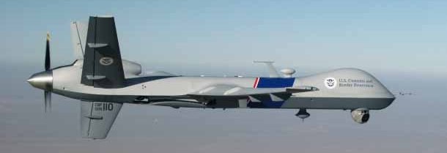
Homeland Security required that this Predator drone, built by General Atomics, be capable of detecting whether a standing human at night is "armed or not." (Credit: U.S. Department of Homeland Security)
The U.S. Department of Homeland Security has customized its Predator drones, originally built for overseas military operations, to carry out at-home surveillance tasks that have civil libertarians worried: identifying civilians carrying guns and tracking their cell phones, government documents show.
The documents provide more details about the surveillance capabilities of the department's unmanned Predator B drones, which are primarily used to patrol the United States' northern and southern borders but have been pressed into service on behalf of a growing number of law enforcement agencies including the FBI, the Secret Service, the Texas Rangers, and local police. But . . . they NEVER built the fence promised for the southern border did they? DHS has told the Border Patrol to 'stand down' . . . why?
Homeland Security's specifications for its drones, built by San Diego-based General Atomics Aeronautical Systems, say they "shall be capable of identifying a standing human being at night as likely armed or not," meaning carrying a shotgun or rifle. They also specify "signals interception" technology that can capture communications in the frequency ranges used by mobile phones, and "direction finding" technology that can identify the locations of mobile devices or two-way radios.
The Electronic Privacy Information Center obtained a partially redacted copy of Homeland Security's requirements for its drone fleet through the Freedom of Information Act and published it this week. CNET unearthed an unredacted copy of the requirements that provides additional information about the aircraft's surveillance capabilities.

Homeland Security's Predator B drone can stay aloft conducting surveillance for 20 hours.
(Credit: U.S. Department of Homeland Security)
What they don't tell you is this . . . see my comments in pink:
Concern about domestic use of drones is growing, with federal legislation introduced last month that would establish legal safeguards, in addition to parallel efforts underway from state and local lawmakers. The Federal Aviation Administration recently said that it will "address privacy-related data collection" by drones. Ha, ha, ha, when do you think they will address 'privacy-related data' . . . will that be BEFORE or AFTER they gather it?
The prospect of identifying armed Americans concerns Second Amendment advocates, who say that technology billed as securing the United States' land and maritime borders should not be used domestically. Michael Kostelnik, the Homeland Security official who created the program, told Congress that the drone fleet would be available to "respond to emergency missions across the country," and a Predator drone was dispatched to the tiny town of Lakota, N.D., to aid local police in a dispute that began with reimbursement for feeding six cows. The defendant, arrested with the help of Predator surveillance, lost a preliminary bid to dismiss the charges. What is left unsaid in this article is that those cows wandered onto a neighbors land and by LAW they are his to keep if he chooses. That's why you should be friends with your neighbors.
HOWEVER, the law showed up at the gate of the farmer who had the cows, and the owners turned the armed police away with their own guns standing on their own private property. That pissed off the sheriff . . . so . . . they fired up the drones to take them down. That's the new normal.
No legal service or court appearances just 'round 'em up' with drones FIRST . . . THEN JAIL THEM, THEN go to court! It was over COWS for heavens sakes. They didn't rob a bank, threaten anyone with a weapon, they claimed their 'rights' as farmers, even if you don't believe they were entitled to that, it is for the courts to determine, NOT some drone happy sheriffs.
"I am very concerned that this technology will be used against law-abiding American firearms owners," says Alan Gottlieb, founder and executive vice president of the Second Amendment Foundation. "This could violate Fourth Amendment rights as well as Second Amendment rights."
Homeland Security's Customs and Border Protection agency declined to answer questions about whether direction-finding technology is currently in use on its drone fleet. A representative provided CNET with a statement about the agency's unmanned aircraft systems (UAS) that said signals interception capability is not currently used: If not now . . . when?
U.S. Customs and Border Protection is not deploying signals interception capabilities on its UAS fleet. Any potential deployment of such technology in the future would be implemented in full consideration of civil rights, civil liberties, and privacy interests and in a manner consistent with the law and long-standing law enforcement practices. Does anyone out there believe such lies, in light of all the violations they have already committed?
CBP's UAS program is a vital border security asset. Equipped with state-of-the-art sensors and day-and-night cameras, the UAS provides real-time images to frontline agents to more effectively and efficiently secure the nation's borders. As a force multiplier, the UAS operates for extended periods of time and allows CBP to safely conduct missions over tough-to-reach terrain. The UAS also provides agents on the ground with added situational awareness to more safely resolve dangerous situations. Why should we believe they will secure the borders NOW when they haven't done that in TWENTY years or more? Remember the 'fence' that was supposed to be erected and NEVER was? Why do we need drones when a fence installed YEARS ago, would have already done the job and some 25-35 million illegals would not be here in America today.
During his appearance before the House Homeland Security committee, Kostelnik, a retired Air Force major general who recently left the agency, testified that the drones' direction-finding ability is part of a set of "DOD capabilities that are being tested or adopted by CBP to enhance UAS performance for homeland security." CBP currently has 10 Predator drones and is considering buying up to 14 more. Believe me . . . those numbers will escalate dramatically once the camel's nose in under the tent!
If the Predator drones were used only to identify smugglers or illegal immigrants crossing the Mexican and Canadian borders, or for disaster relief, they might not be especially controversial. But their use domestically by other government agencies has become routine enough -- and expensive enough -- that Homeland Security's inspector general said (PDF) last year that CBP needs to sign agreements "for reimbursement of expenses incurred fulfilling mission requests." Boy, there's joke for you . . . the borders have been left DELIBERATELY OPEN for DECADES and they justify the drones for identifying illegal immigrants.
"The documents clearly evidence that the Department of Homeland Security is developing drones with signals interception technology and the capability to identify people on the ground," says Ginger McCall, director of the Open Government Project at the Electronic Privacy Information Center. "This allows for invasive surveillance, including potential communications surveillance, that could run afoul of federal privacy laws." They already have . . . and there will be no end, unless we rise up and stop them. Snip . . .
—————————————————————————————————————————————
And . . . Who Will Build Those Drones Financed By Our Tax Dollars?
—————————————————————————————————————————————
Colleges, and universities are behind the creation, proliferation, management, and use of drones. There are 'big bucks' in it for them. Those are the same universities that are, owned and run by the elite who will use your tax dollars to surveil you and your family. See my comments in pink:
Go back to school for a bachelor’s in piloting drones
http://www.smartplanet.com/blog/bulletin/go-back-to-school-for-a-bachelors-in-piloting-drones/15979 (3-26-13)
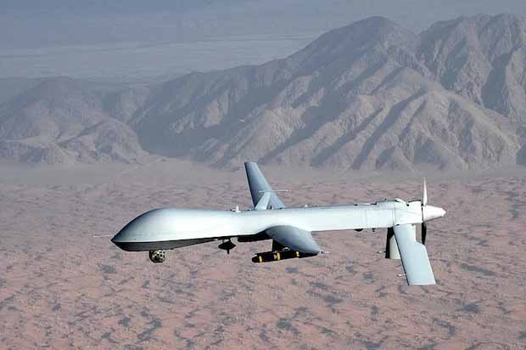
There will be 10,000 commercial drones operating in the U.S. within five years, the Federal Aviation Administration predicts. The industry will produce 100,000 jobs by 2025. Camera drones alone are expected to be a $5 billion industry.
All these remotely piloted systems will need feet-on-the-ground fliers, and colleges are revving up their piloting programs.
Only three schools offer bachelor’s degrees for piloting unmanned aircraft: Kansas State University, University of North Dakota, and Embry-Riddle Aeronautical University in Daytona Beach (where you can study homeland security).
There’s a shortage of pilots right now, according to Embry-Riddle’s Dan Macchiarella. The shortage should continue to grow even as some current conflicts draw down.
The government has issued permits for research and border security to 358 public institutions, including community colleges, NBC News explains. But police departments requesting them for high crime areas have been rejected over concerns about airspace safety. Notice there is no mention of those 'private' institutions. That's to suck you into their schemes hoping that you will support them by helping ordinary everyday common people will get those jobs.
However, when the FAA releases regulations for unmanned aircraft in domestic airspace in 2015, drones will start doing things they haven’t done previously.
So, how is training for a drone different from regular pilot training? Macchiarella tells IEEE Spectrum:
Presence is the key… If a pilot is on the other side of the world flying a vehicle, they have to mentally put themselves in that aircraft and fly it.
Simulators… it’s there to induce the pilot to making the right decisions, taking the right actions, but it’s not really flight… With UA, unmanned aerial systems, however, the simulator and the actual system are identical. There’s no difference.
The Department of Defense plans to spend $4.2 billion on drones this year.
Engineering and computer science students are also in demand. At least 50 American universities have programs where students are making drones smarter with sensors and studying robot-human interacts. For a country in decline job wise, and because they have shipped all our manufacturing overseas, they have created a new avenue for potential jobs. They are hoping that the American people will FLOCK to them by disregarding the fact that they will become part of the draconian surveillance society spying on their family, friends and neighbors.
—————————————————————————————————————————————

Here's The Proof !
—————————————————————————————————————————————
Drone Piloting Degrees Take Off on College Campuses (3-27-13)http://www.nationalreview.com/corner/344065/drone-piloting-degrees-take-college-campuses-andrew-johnson
With commercial drones set to hit the sky in a few years, American universities are stepping up to meet the demand for pilots by offering degrees in drone piloting.

Kansas State University and the University of North Dakota have established Unmanned Aircraft Systems (UAS) programs that educate students about drones both in the classroom and in the field. Kansas State, according to its website, now offers a “Bachelor of Science in Unmanned Aircraft Systems (UAS)”; instructors use “a hands-on approach for learning and attaining the skills needed to safely operate and manage UAS — it’s what sets K-State apart from the rest.” Florida’s Embry-Riddle Aeronautical University has also expanded its curriculum, which now includes drone piloting.
The executive director of KSU’s Applied Aviation Research Center, Kurt Barnhart, emphasizes the cutting-edge nature of the school’s program in a promotional video. “The exciting thing about this is that we’re at the outset of this industry,” he says. “It’s growing, and the civilian airspace is opening up in a few years, and so we’re training the operators to take advantage of that window when it opens very shortly.”
Universities are educating students to fill jobs that are expected to materialize in the coming years. The drone industry will create 70,000 jobs in the first three years after the introduction of commercial drones, expected in 2015, according to SmartPlanet, and, by 2025, drones will create an estimated 100,000 jobs. Does anyone out there realize HOW MUCH SPYING they will do?
Under the State Department’s International Traffic in Arms Regulations, degrees are only open to U.S. citizens. Yes . . . do make sure that Americans spy on Americans, that makes if okay!
—————————————————————————————————————————————
Documents Expose Predator [Reaper] Drones Spying Extensively in U.S. http://www.infowars.com/documents-expose-predator-drones-spying-extensively-in-u-s/ (7-4-13)
U.S. Customs and Border Protection is now lending Predator drones to a wide range of federal, state, and local agencies for domestic surveillance and possible “non-lethal” strikes, according to federal documents released by the Electronic Frontier Foundation.
The FBI, the U.S. Marshals and even the Texas Department of Public Safety have used CBP Predator drones in U.S. airspace. In 2010, CBP reported that future drone payloads could include “non-lethal weapons designed to immobilize targets of interest.”
Last month, FBI Director Robert Mueller admitted that the FBI has used drones domestically.
The new documents expose the wide extent of domestic drone use. The EFF released the documents after a Freedom of Information Act lawsuit.
CBP drone use by other agencies has increased over eight times from 2010 to 2012.
By 2016, CBP wants airborne drones in domestic airspace 24 hours a day, seven days a week to ensure a “layered security strategy.” When they say 'layered' they mean you will not be able to hide anywhere from them. They will be omnipresent.
Predator drone mission data can be fused into an information sharing center for federal, state, and local agencies across the country.
This drone data center would operate like current Homeland Security fusion centers which have violated Americans’ civil liberties and privacy according to a two-year Senate investigation.
—————————————————————————————————————————————
New Documents Show Military Is Flying Drones Throughout US
http://www.infowars.com/new-documents-show-military-is-flying-drones-throughout-us/ (12-6-12)
"Feeds from those drones can be fed into artificial-intelligence software developed by DARPA known as the “Mind’s Eye project”, which can analyze all the data at once, meaning that essentially a machine can keep watch over everything happening in an entire city."
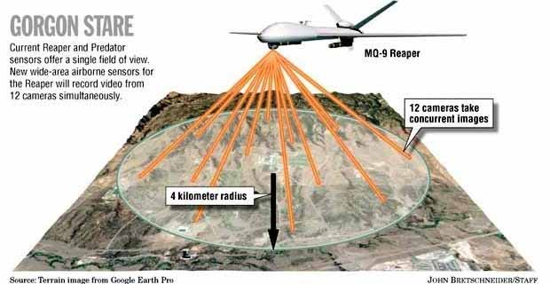
The next generation drones will have a 100 cameras on board.
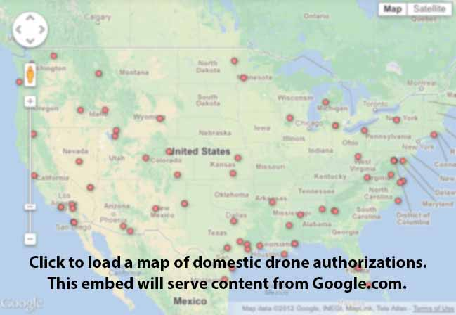
—————————————————————————————————————————————

There Are DOZENS Of Miniature Type Drones Being Created
—————————————————————————————————————————————
This is but ONE of the miniature drones . . .
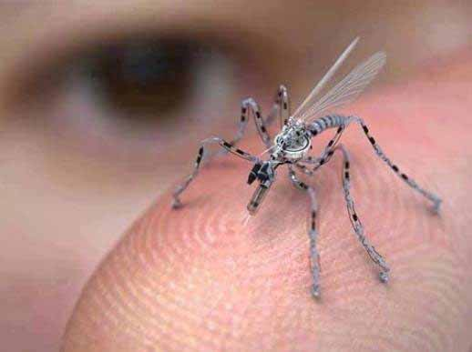
Is this a mosquito? No. It's an insect spy drone for urban areas, already in production, funded by the US Government [that's our tax dollars], It can be remotely controlled and is equipped with a camera and a microphone. It can land on you, and it may have the potential to take a DNA sample or leave RFID tracking nanotechnology on your skin. It can fly through an open window, or it can attach to your clothing until you take it in your home. Given their propensity to request macro-sized drones for surveillance, one is left with little doubt that police and military may look into these gadgets next.
—————————————————————————————————————————————

Screenshot from YouTube user raytheoncompany
Pentagon to Deploy Blimps Over Washington, DC for 360-degree Surveillance (8-1-13) http://www.thesleuthjournal.com/pentagon-to-deploy-huge-blimps-over-washington-dc-for-360-degree-surveillance/
The airships are part of Raytheon’s Joint Land Attack Cruise Missile Defense Elevated Netted Sensor System, or JLENS, and when all is said and done they’ll offer the United States military what the defense contractor calls “an affordable elevated, persistent over-the-horizon sensor system” that relies on “a powerful integrated radar system to detect, track and target a variety of threats.”
Raytheon has just wrapped up a six-week testing period in the state of Utah and is now sending its JLENS fleet to the Aberdeen Proving Ground in Maryland. Once there, the Army intends to get some hands-on experience that will eventually culminate in launching the pair of airships over Washington, DC.
Once above the nation’s capital, JLENS will allow the Army to see for 320 miles in any direction from 10,000 feet above the earth. The system can be set up to operate on its own for an entire month without requiring refueling, and offers the Pentagon surveillance capabilities that dwarf other options at a penny of the cost.
Its manufactures say JLENS “enables commanders to defend against threats including hostile cruise missiles, low-flying manned and unmanned aircraft, tactical ballistic missiles, large caliber rockets and moving surface vehicles such as boats, SCUD-launchers, automobiles and tanks.”
“Affordable defense from real world threats,” Raytheon touts the system on its website.
—————————————————————————————————————————————
7 months later . . . Stage II:
Giant Military Surveillance Blimps To Constantly Monitor East Coast
http://motherboard.vice.com/en_au/blog/a-giant-military-surveillance-blimp-is-going-to-constantly-monitor-the-east-coast (2-23-14)
. . . the entire mid-Atlantic region will, at least, have the potential to be under “persistent surveillance,” a dream term for those in the intelligence biz and a worst-case scenario for those who care a lick about privacy. One aerostat that was tested in Utah last year was able to follow individual vehicles “dozens of miles away” and watch a test subject plant a fake bomb on the side of the road. According to the Washington Post, the Army has “no current plans” to use that high-powered video sensor in Maryland, but wouldn’t rule out using it in the future.
JLENS also doesn’t have to focus on just one target at a time. According to Raytheon, it can “track hundreds of airborne and surface moving threats, in 360 degrees.” And it’ll be flying full time by the end of the year.
—————————————————————————————————————————————
Surveillance Drones Archive . . .
—————————————————————————————————————————————
1. The Drones Come Home
http://ngm.nationalgeographic.com/2013/03/unmanned-flight/horgan-text (March 2013)
2. Is Your State One of the Six Chosen For Drone Testing in 2014?
http://www.thesleuthjournal.com/state-one-six-chosen-drone-testing-2014 (1-3-14)
3. Massive US airships to conduct 24/7 domestic aerial surveillance http://www.fourwinds10.net/siterun_data/government/fraud/us_government/news.php?q=1391019555
(1-29-14)
4. Is Your Town on the Map? FAA Releases New Drone List of 81 New Applicants
http://www.fourwinds10.net/siterun_data/government/weapons/news.php?q=1360426729 (2-8-13)
5. FAA is gearing up to spy on regular Americans: Agency admits drone operators have NO privacy obligations http://www.naturalnews.com/z041369_FAA_drone_operators_privacy.html (1-27-13)
—————————————————————————————————————————————

America Has Become A War Zone
—————————————————————————————————————————————
The Terrifying Future of The United States
http://www.youtube.com/watch?v=1rwmD4c_NxI (11:58)
This reveals the esposure of the incrementalism being used to keep you from rising up against their plans.
—————————————————————————————————————————————
Defense Department gives local police equipment designed for a war zone http://www.foxnews.com/us/2013/11/27/defense-department-gives-local-police-equipment-designed-for-warzone/
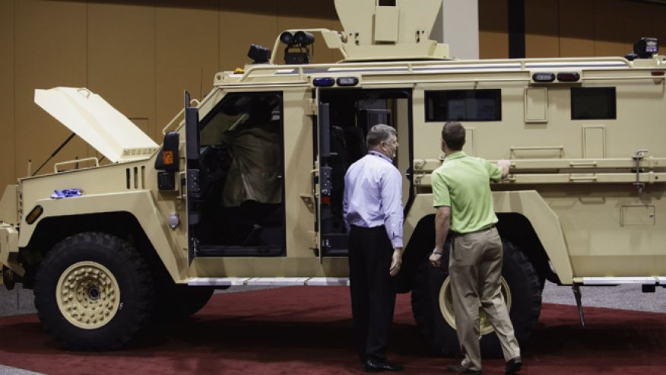
Bigger toys . . .
11-27-2013 FoxNews.com
Attendees look at the Lenco MRAP Bear SWAT Team vehicle at the 7th annual Border Security Expo in Phoenix, Arizona March 12, 2013.
Credit: Reuters/Joshua Lott
From war zones to city streets, some military vehicles are getting a new life -- and not everyone is happy about the recycling.
The Defense Department recently announced it would be giving domestic law enforcement forces hulking vehicles designed to efficiently maneuver in a war zone for use in thwarting any potential high-scale activity.
This did not sit well with those who see a troubling trend: the militarization of local police departments, including the American Civil Liberties Union, which has criticized the Defense Department for giving 18-ton, $500,000 armor-protected military fighting vehicles to local forces.
—————————————————————————————————————————————
Latest Homeland Security Armored Vehicle
http://modernsurvivalblog.com/government-gone-wild/latest-homeland-security-vehicle-street-sweeper/ (9-6-12)

Of the nearly 9,000 delivered MaxxPro units to the military, the Department of Homeland Security is apparently taking delivery (apparently through the U.S. Army Forces Marine Corps Systems Command, Quantico VA, via the manufacturer – Navistar Defense LLC) of an undetermined number of the recently retrofitted 2,717 ‘Mine Resistant Protected’ MaxxPro MRAP vehicles for service on the streets of the United States.
As these MRAP’s return from overseas/Afghanistan, and although it is apparently unknown exactly how many are being delivered, or have been delivered to DHS . . . 
——————————————————————————————————————————-
Column: The militarization of U.S. police forces
http://www.reuters.com/article/2013/10/22/us-opinion-shank-idUSBRE99L12420131022 (10-22-13)
This month, more Mine-Resistant Ambush-Protected vehicles (MRAPs) have found their way from the wars in Afghanistan and Iraq to the Main Streets of America. These are just the latest acquisitions in a growing practice by Pentagon that's militarizing America's municipal police forces.
Police departments in Boise and Nampa, Idaho, each acquired an MRAP, as did the force in High Springs, Florida. The offer of war-ready machinery, at practically no cost, has proven hard to resist for local police departments. Increasingly, they are looking like soldiers equipped for battle.
The growing similarity between our domestic police forces and the U.S. military is a result of the Pentagon's 1033 Program. This allows the Defense Department to donate surplus military equipment and weapons to law enforcement agencies. In addition to the frightening presence of paramilitary weapons in American towns, the program has led to rampant fraud and abuse.
It does not have to be this way. Congress can, and must, take decisive steps to scale back the program and demilitarize American police forces. Here's how to do it.
First, Congress should permanently ban the transfer of all military-grade equipment to our cities. The program has already transferred enough impractical machinery to local police forces — material that many police departments do not have the skill to use safely or the money to maintain. Georgia's Cobb County, for example, acquired one AR-15 assault rifle for each of its patrol vehicles, while Tupelo, Mississippi received a helicopter that needed $100,000 worth of upgrades and $20,000 each year in maintenance.
Due to the large amount of missing weapons, the Pentagon has now temporarily suspended new weapons shipments to domestic law enforcement agencies. This is a good step. But it is not enough — especially since the ban is expected to be lifted soon.
—————————————————————————————————————————————

Read This and Weep . . . Electromagnetic Radiation as a WEAPON
—————————————————————————————————————————————
Dahr Jamail: Navy Plans Electromagnetic War Games Over National Park and Forest in Washington State http://www.fourwinds10.net/siterun_data/environment/pollution/news.php?q=1416419264 (11-17-14)

An EA 18G Growler from the Shadowhawks of Electronic Attack Squadron (VAQ) 141 takes off.
(Photo: Mass Communications Specialists 3rd Class Bradley J. Gee / US Navy)

Olympic National Park and Olympic National Forest in Washington State are two of the most beautiful wilderness areas in the United States. Majestic glacier-clad peaks rise above temperate rainforest-covered hills. Gorgeous rivers tumble down from the heights and the areas are home to several types of plants and animal species that exist nowhere else on earth.
These protected national commons are also the areas in and near where the US Navy aims to conduct its Northwest Electromagnetic Radiation Warfare training program, wherein it will fly 36 of its EA-18G "Growler" supersonic jet warplanes down to 1,200 feet above the ground in some areas in order to conduct war games with 14 mobile towers. Enough electromagnetic radiation will be emitted so as to be capable of melting human eye tissue, and causing breast cancer, childhood leukemia and damage to human fetuses, let alone impacting wildlife in the area.
What is at stake is not just whether the military is allowed to use protected public lands in the Pacific Northwest for its war games, but a precedent being set for them to do so across the entire country.

The following 3 Photos are by Dahr Jamail


—————————————————————————————————————————————
Now you know why the Federal Gov't is striving to forbid photography in our National Forests and Parks!
—————————————————————————————————————————————

US Forestry Service wages war on photography in national forests
http://boingboing.net/2014/09/26/us-forestry-service-wages-war.html (9-26-14)
The U.S. Forest Service Wants to Fine You $1,000 for Taking Pictures in the Forest http://www.esquire.com/blogs/news/1000-dollar-fine-for-pictures-in-the-forest (9-24-14)
7 things you should know about the Forest Service's media restrictions in wilderness http://www.oregonlive.com/environment/index.ssf/2014/09/7_things_you_should_know_about.html (9/24/14)
Forest Service delaying media wilderness photography rules amid growing outcry about the 1st Amendment
http://oregon.citynewsline.com/news/forest-service-delaying-media-wilderness-photography-rules-amid-growing-outcry (9-25-14)
Forest Service clarifies proposal on news photos in wilderness, after First Amendment outcry http://www.foxnews.com/politics/2014/09/27/forest-service-clarifies-proposal-on-news-photos-in-wilderness-after-first/ (9-27-14)

'They' WILL eventually forbid all photos in our Parks and Forests, on the grounds of National Security!

—————————————————————————————————————————————
Lastly THE Most Egregious of ALL ~ SMART METERS & Cell Phone Towers
—————————————————————————————————————————————
Because Smart Meters and cell phone towers will directly effect EVERY LIVING HUMAN BEING on this planet who lives near them . . . this section is EXTREMELY IMPORTANT!
Pay attention here and watch, and/or purchase the latest and most telling video about Smart Meters.
You need to watch all the parts of it, many automated sequential uploads can be found here: https://www.youtube.com/watch?list=UUBmSbCRd_Jj5NgV3xTwrkHA&v=eAjX6Ap02dU&feature=player_embedded
OR . . . do as I did, and purchase the DVD titled: Take Back Your Power, which can be found here: http://www.takebackyourpower.net/
—————————————————————————————————————————————
The widely unreported dangers of electromagnetic pollution
http://www.naturalhealth365.com/electromagnetic-fields-cell-phone-radiation-1211.html (11-13-14)
—————————————————————————————————————————————
The following is an article I wrote about my PERSONAL challange to the Smart Meter, which 'they' have renamed 'Advance Meters' in Alabama to subvert their TRUE mission . . .
Smart Meter Extortion Charges ~ a Violation of Alabama Law
http://www.fourwinds10.net/siterun_data/health/harmful_products/news.php?q=1404314939 (6-30-14)
I recently received a letter from the Baldwin County, Alabama, EMC (Electric Membership Co-Op) demanding a charge of $40 PER MONTH in order to continue reading my old analog electric meter.
I am 75 years old and my husband is 80 years old and we live on social security. That $40 per month equals $480 per year. That $480.00 per year is EQUAL to a MINIMUM of four average months of electric use. This demanded $40 per month charge to read the old meters is EXTORTION in order to force those VERY HARMFUL electric Smart Meters to be attached to our home . . . right next to our bedroom.
In addition, the LIES espoused in the EMC Frequently asked Question brochure can ALL be refuted. I have done extensive research on those Smart Meters, which EMC has been renamed as Advanced Meters, so that they can distance themselves from all the complaints and research about Smart Meters. Below . . . you will find that those 'Advanced Meters' (Smart Meters) comply with the UN's Agenda 21 program, which is FORBIDDEN by Alabama law.
One of the lies they state in the EMC literature is that 'it is not possible to detect use of individual appliances with this meter'. That is simply NOT TRUE. Those meters can be upgraded, whenever they decide to invoke ever more massive and invasive information, by using the RFID chips in your meters and/or energy star appliances.
EMC asks Is your new meter SAFE? . . . the answer is . . . NO! Although the FCC has approved of them, they are NOT approved by the Underwriters Laboratory (UL) and can cause house fires. So what does that say about the FCC approval? https://en.wikipedia.org/wiki/Underwriters_Laboratories
Lastly, you need to understand that anything connected the Agenda 21, which is part of the globalists power grab of the world called . . . the New World Order, you will find that the plutocratic oligarchs, who currently rule our world, intend to enslave us by using Smart Meters to create a WORLD WIDE 'SMART GRID'. If you don't believe me, then watch the following videos and join the awakening!

—————————————————————————————————————————————

The Following Smart Meter Videos Are Listed In Order Of Significance
—————————————————————————————————————————————
The Truth About Smart Meters - Brian Thiesen
http://www.youtube.com/watch?feature=player_detailpage&v=v4HsxNG2-4M (1:08:15)
—————————————————————————————————————————————
Technocracy, Sustainable Development and the SMART Grid http://vimeo.com/28247826 (37:97)
Watch this highly researched and shocking explanation of SMART Meters and how they fit into "Technocracy" to totally control people. Patrick Wood explains at the 2011 Eagle Forum Conference in Santa Rosa, CA.
—————————————————————————————————————————————
The Truth About Smart Meters - CTV Santa Cruz County, CA (1:53:41)
https://www.youtube.com/watch?v=p-nmaYU6kek&feature=related
—————————————————————————————————————————————
Deborah Tavares Interview : Agenda 21 - Global SMART GRID (1:03:11)
https://www.youtube.com/watch?v=yYxAkFY_aTw
—————————————————————————————————————————————

Activist, Educator and Lecturer - Deborah Tavares is interviewed
https://www.youtube.com/watch?v=HvzLirkx4as (1:07:09)
—————————————————————————————————————————————
National Day of Action Against Smart Meters with Jerry Flynn who is a former Captain in the Communications Electronics Engineering Branch of the Royal Canadian Navy.
https://www.youtube.com/watch?v=c-F3nf47kAs (1:27:17)
—————————————————————————————————————————————
For those of you who like to read . . . here are two EXCELLENT research papers!
Public health Implications of wireless technologies
http://stopsmartmeters.org/wp-content/uploads/2012/03/Sage-Carpenter-Public-Health-Implications-Wireless-Tech.pdf 1/30/09
—————————————————————————————————————————————
Radiofrequencey Radiation: The Invisible Hazards of "Smart'' Meters
http://www.globalresearch.ca/radiofrequency-radiation-the-invisible-hazards-of-smart-meters/26082 8-19-2011
—————————————————————————————————————————————
My Position . . .
—————————————————————————————————————————————
For health reasons, I maintain that it is my right to keep my old analog electric meter. That right is being infringed by an extortion demand from EMC (Electric Membership Co-Op) that requires me to fork over $40 EVERY MONTH to have my old analog meter read, as it was ALWAYS done in the past . . . for FREE.
That's not to mention that these new Advanced Meters (aka Smart Meters) can harm my health and WILL COST HUNDREDS of dollars each. Those meters will need replacing as the technology advances (think cell phone upgrades here), as opposed to the old meters which have, and will last, for MANY DECADES.
—————————————————————————————————————————————
Alabama FORBIDS ANYTHING Connected With
The UN Agenda 21 . . . Being Forced Upon Us
—————————————————————————————————————————————
Alabama Enacts Law To Stop UN Agenda 21
http://toryaardvark.com/2012/06/09/alabama-enacts-law-to-stop-un-agenda-21/ (6-9-12)
Using strong and specific language, SB 477 orders all state agencies to refuse to cooperate in any UN scheme to subvert the sovereignty of Alabama. It says . . .
“The State of Alabama and all political subdivisions may not adopt or implement policy recommendations that deliberately or inadvertently infringe or restrict private property rights without due process, as may be required by policy recommendations originating in, or traceable to ‘Agenda 21.’
The final vote for SB 477: http://legiscan.com/AL/text/SB477/id/645326
The House vote was . . . Yea: 96 – Nay 0

The Senate vote was . . . Yea: 32 – Nay: 0
Alabama Adopts First Official State Ban on UN Agenda 21http://www.thenewamerican.com/rio-20/item/11592-alabama (6-4-12)
UN Agenda 21 Outlawed In Alabama
http://education-curriculum-reform-government-schools.org/w/2012/06/un-agenda-21-outlawed-alabama/ (6-26-12)
Alabama to Agenda 21: Get Lost
http://www.westernjournalism.com/alabama-to-agenda-21-get-lost/ (6-15-12)
WINNING THE FIGHT: ALABAMA - DEMOCRATS AGAINST U.N. AGENDA 21
http://www.democratsagainstunagenda21.com/the-way-we-see-itour-blog/winning-the-fight (6-7-12)
—————————————————————————————————————————————
IF YOU STILL DON'T GET IT - WATCH ALL THE COMPONENTS PARTS OF AGENDA 21
—————————————————————————————————————————————
“UN Agenda 21/Sustainable Development is the action plan, implemented worldwide, to inventory and control all land, all water, all minerals, all plants, all animals, all construction, all means of production for all energy, all education, all information, and all human beings in the world as INVENTORY AND CONTROL.”
Agenda 21 For Dummies: http://www.youtube.com/watch?feature=player_embedded&v=TzEEgtOFFlM (9:30)
—————————————————————————————————————————————

Smart Meters Outsmarting America: Agenda 21 in You Home
http://www.youtube.com/watch?v=8JNFr_j6kdI&feature=player_embedded (4:32)
—————————————————————————————————————————————
Jerry Day, an electronics and media expert from Burbank California, recently detailed many of the ways that smart meters act as surveillance devices when they are installed in our homes….
- They individually identify electrical devices inside the home and record when they are operated causing invasion of privacy.
- They monitor household activity and occupancy in violation of rights and domestic security.
- They transmit wireless signals which may be intercepted by unauthorized and unknown parties. Those signals can be used to monitor behavior and occupancy and they can be used by criminals to aid criminal activity against the occupants.
- Data about occupant’s daily habits and activities are collected, recorded and stored in permanent databases which are accessed by parties not authorized or invited to know and share that private data.
- Those with access to the smart meter databases can review a permanent history of household activities complete with calendar and time-of-day metrics to gain a highly invasive and detailed view of the lives of the occupants.
- Those databases may be shared with, or fall into the hands of criminals, blackmailers, law enforcement, private hackers of wireless transmissions, power company employees, and other unidentified parties who may act against the interests of the occupants under metered surveillance.
- “Smart Meters” are, by definition, surveillance devices which violate Federal and State wiretapping laws by recording and storing databases of private and personal activities and behaviors without the consent or knowledge of those people who are monitored.
- It is possible for example, with analysis of certain “Smart Meter” data, for unauthorized and distant parties to determine medical conditions, sexual activities, physical locations of persons within the home, vacancy patterns and personal information and habits of the occupants.
Water and gas meters are next . . .
—————————————————————————————————————————————
Lastly . . . House Fires Due To Defective Smart Meters
—————————————————————————————————————————————

Smart Meter Fires and Explosions
http://emfsafetynetwork.org/smart-meters/smart-meter-fires-and-explosions/
The above is a compilation of reports from the US, Australia and Canada about fires, explosions or burned out appliances due to Smart Meter installations. If you have experienced similar problems, please post your story in the comment section at the bottom of the article.
The US Consumer Products Safety Commission (CPSC) is a federal agency that will take complaints on utility smart meters from all US states. If you have or had smart meter electrical or fire problems CALL: (800) 638-2772 Monday through Friday from 8:00 a.m. to 5:30 p.m. ET or submit your complaint by email.
—————————————————————————————————————————————
Meters that Endanger:
Shocking Details from a Whistleblower
http://stopsmartmeters.org/2012/01/20/meters-that-endanger-shocking-details-from-a-whistleblower/ (1-20-12)
The Law Suit:
http://www.scribd.com/doc/101281662/Alabama-Baker-Sensus-Complaint (5-25-10)
—————————————————————————————————————————————
Thorner: Com Ed's Smart Meters Poke Holes In Privacy Walls
http://blog.heartland.org/2014/05/thorner-com-eds-smart-meters-poke-holes-in-privacy-walls/ (5-12-14)

—————————————————————————————————————————————
So . . . it CAN be Done!
—————————————————————————————————————————————
Success: The end of "smart" meters in Port Angeles, Washington
http://www.takebackyourpower.net/?p=12921&upm_export=print (11-30-14)
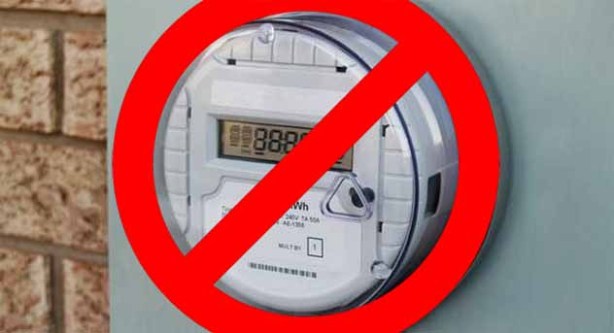
by Dr. Frank Springob . . .If you have seen Take Back Your Power, you know me as the one who created the darkfield images of blood samples from three different people before and after a two-minute exposure to the smart meter installed at my office.
Recall the damaging effect of the smart meter exposure on the blood cell membranes. It was a very visual example of the dangerous emissions that I was exposed to continuously for several years.
I am now pleased to say that my smart meter has been removed now that the installation program has been scrapped, thanks to the efforts of many of our local awake and informed group.
—————————————————————————————————————————————
If you cannot imagine WHAT they will do with the information that the Smart Meters and Cell Phone Towers will provide for the NSA. Read on!
—————————————————————————————————————————————
Cell Towers Cause CANCER - If You Live Near Them . . . Don't!
—————————————————————————————————————————————
New study links over 7,000 cancer deaths to cell phone tower radiation exposures
http://www.naturalnews.com/z040905_cell_phone_towers_radiation_cancer.html
The BioInitiative 2012 Report written by a group of leading independent international scientists has put out an unequivocal health warning against exposure to EMFs. This includes exposures from cell phone towers.
Why are cell phone towers particularly dangerous?
The threat comes from the constant nature of the activity of the towers; they emit pulsed radio frequency radiation. This radiation has been shown in thousands of studies to cause biological damage to the body and to be a precursor to disease.
What are some of the dangers (besides cancer), which result from this damage and are associated with EMFs and cell phone antennae?
• Genetic mutations • Brain disorders
• Memory disruptions • Hormonal imbalances
• Hindered learning • Infertility
• ADD • Dementia
• Insomnia • Heart complications
These dangers clearly make it imperative to take action.
Cell towers are here to stay but their implantation needs effective regulation in terms of location and radiation levels. The 1996 Telecommunications Act (TCA), does not qualify the public's right to protest cell tower locations based on health hazards. Cell towers should be located away from residential areas and far away from schools and day care centers.
—————————————————————————————————————————————
Be Aware: These Cell Phones Can Emit 28 Times More Radiation
http://www.fourwinds10.net/siterun_data/health/harmful_products/news.php?q=1308664683 (6-18-11)
An "Elephant in the Room"?
On a final note, Camilla Rees of ElectromagneticHealth.org cautions that while the IARC decision was a true watershed event, especially given IARC's own 13-country Interphone study downplayed brain tumor risk when published last May, with news headlines heralding "No Risk Found", she says:
"This first IARC classification is just the tip of the iceberg. There is a big elephant in the room most people are not seeing.
Microwave radiation emitted by cell phones is the same kind of radiation emitted by other wireless technologies, such as WiFi routers, portable phones, wireless baby monitors and cell towers.
The distinction is that the cell phone has more power at the head, and they operate at different frequencies. But given society is blanketing itself in this radiation at a range of frequencies, and the radiation is known to cause DNA damage, cancer, impaired fertility, cognitive impairment, such as memory changes, interference with learning and wildlife and ecosystem effects, we feel it is urgent that federal research funding be immediately allocated to examining this issue in the broader sense, far beyond the cell phone and brain tumor issue"
VIEW VIDEO
http://emf.mercola.com/sites/emf/archive/2011/06/18/finally-experts-admit-cellphones-are-a-carcinogen.aspx (21:57)
—————————————————————————————————————————————
Cell Phone 'Towers' are Not What We Were Lead To Believe http://www.fourwinds10.net/siterun_data/environment/weather_and_climate/news.php?q=1369403144 (5-21-13)
What we call cell towers are absolutely not needed. They are often heavily fortified, are always fed at least 50,000 watts, often fed half a million watts, and typically spaced four miles apart, to give a signal radius of two miles per tower. Something is wrong with that.
The proof of how powerful they are is indicated by the size of the transformers feeding them, which are often 500KVA and Farganne even photographed and sent me the picture of one that had to be at least a megawatt.
WLS in Chicago transmits with five percent of that – (50,000 watts,) and can be heard clearly for over a thousand miles at all hours of the day with a reasonable radio, and often comes in clearly nationwide.
So why do what we call “cell towers” often get fed 10 TIMES THAT to talk to a cell phone two miles away?
. . .
Is Haarp right in front of us, in plain sight?
There are over 200,000 cell nodes in America alone. Let´s just assume that half of them are not part of any clandestine system. What about the other half?
Well, to be on the conservative side, let´s just say they get the minimum 50,000 watts. 50,000 watts X 100,000 “cell towers” equals FIVE BILLION WATTS. Haarp in Alaska is rated at less than 100 million. So obviously then, the cell towers have a lot more kick.
That is a conservative guess – the actual number should probably be based on each cell tower having 250,000 watts because I have never seen a cell tower with a transformer smaller than that here is what a 250,000 watt (250 KVA) transformer looks like..

A transformer of this size, as small as it looks, can furnish 5 times the power that WLS broadcasts with. A small pad mounted knee high transformer in a local neighborhood can more than feed a 50,000 watt transmitter. But a big number is a big number any way you cut it, so it is probably irrelelvant.
I always thought it a little far fetched to think that Haarp in Alaska could affect the weather anywhere in the world, because the earth is curved, and to affect the weather in another location you would need to depend upon ionospheric bounce to get your signal to it´s destination and that is not predictable.
However, I certainly can buy into locally produced weather, where every cell tower in a region is fired up in a symphony of madness to cause it.
THAT would be believable, and if Haarp can tap the ionosphere with 50 million watts, to trigger a much larger cascade from the virtually limitless power the ionosphere contains, then the cell towers in a region certainly have enough power to do it.
At 250,000 watts each, which is most probable based on what I have seen feeding most of them, it would only take 200 towers to rival Haarp in Alaska and do it locally, right where the action is supposed to be.
Why stop at 200, when there are at least 100,000 available? For just about any disaster in any region, there will be over 2,000 in close proximity that can team up to get the job done. Need a bigger disaster? Fire up more.
Cell Phone Antennas on Apartment Rooftops and their Health Effects https://www.youtube.com/watch?v=-G3CWrgDS5E&feature=youtu.be (1:49)
—————————————————————————————————————————————
Dangerous Radiation From Hidden Cell Phone Towers (August, 2004) http://www.bibliotecapleyades.net/salud/esp_salud24.htm An 'oldie but goodie' article you need to read!

Here is a quick list of common sources of radiation:
1. CELL PHONES - Here the antenna is very close to the brain, and many studies have been done on this. Recent studies done in Europe show that tumors can be induced in rats, which are exposed to the same power levels and distances that normal cell phone users are from the phone's antenna.
2. CORDLESS PHONES - In reality, these are as detrimental as cell phones because they operate near the microwave frequencies of cell phones (microwave.) In some ways, they could be worse than cell phones because many people spend more time on these.
3. GARAGE DOOR OPENERS - A source of radiation when the button is pressed.
4. WIRELESS PDAs and NOTEBOOK COMPUTERS - These work very much like cell phones, with the same potential effects.
5. MICROWAVE ALARM SYSTEM SENSORS - This is one area NO ONE talks about. These are common in homes and businesses. Although the power level is in the microwatt realm, one may sit exposed to it all day, every day, sometimes just a few feet away. Again, think about it in terms of exposure time vs. energy levels.
6. BLUE TOOTH WIRELESS DEVICES - Operate in the lower microwave region.
7. WIRELESS VIDEO CAMERAS - Operate in the microwave region above analog cell phones.
8. TV EXTENDERS - Used to transmit video and sound without wires from one room to another in a home. These also operate in the microwave region above analog cell phones.
9. SATELLITES - Walk outside, anywhere, and you will be bombarded with RF from satellites, both civilian and military. If you could visibly "see" these sources, you would see points of "light" from the 22,500 mile high Clarke belt of stationary satellites. This belt of satellites rise from the western horizon and arcs across the sky to the east. There will also be hundreds of moving lights in the sky from lower geosynchronous orbits. Some of these are also satellites the military uses that send signals to earth, too.
Many military satellites have high-powered optical sensors, with huge telephoto lenses that watch everything from orbit. These satellites orbit about 200 miles up and contrary to public belief, can actually read a newspaper headline from orbit. The portrayal of distant fuzzy images as seen in "Patriot Games" is far from the truth. And these satellites bombard the earth with more RF radiation as they send their data to earth.
10. POLICE RADIOS - Police officers now have antennas on their microphones, also have a similar risk to that of cell phone users since the antenna is located near the head. There is also radiation from the antennas on their vehicles, too.
11. WALKIE-TALKIE TYPE RADIOS - In decades past, business radios operated in the lower VHF band.
These were known as business band radios, and are still in use today. No known ill effects are known to have originated from these radios. Today's family channel radios operate in the 400Mhz UHF band, near TV channel 14.
12. DOOR OPENERS - Often used in grocery and discount stores, these open the door when you pass under a microwave motion detector. You pass directly under the unit when you enter or exit the store, receiving more microwave radiation.
13. SECURITY FOR STORES - Used in WalMart, video rental and other stores, these exit portals generate an RF field you are forced to walk through upon entering and exiting the store. The square "Be Kind Please Rewind" tag is often a tuned printed circuit behind the label, that will trigger the security system when passed through a portal at the exit. Libraries use a very similar system with thin resonating devices slipped into the spine of books. These systems operate in the lower microwave band, allowing the use of small coils (or no coils at all) because of the high frequencies employed.
14. CELL TOWERS - Last but not least, cell tower antennas which operate at power levels of about 10 watts FOR EACH ANTENNA on the tower. Some use higher wattage than that. These directional antennas divide a geographical area into cells of service.
—————————————————————————————————————————————
Go here to see a visual of the MASSIVE number of Canadian cell towers mapped: http://www.ertyu.org/steven_nikkel/cancellsites.html (11-5-14)
—————————————————————————————————————————————
Enemy of the state: Your cell phone is now a tracking device for NSA to hunt you down http://www.naturealnews.com/z041401_NSA_cell_phone_tracking_drone_strikes.html (7-30-13)
News of the U.S. National Security Agency (NSA)'s covert spying activities on Americans has sent shockwaves throughout the nation, rattling what little rudiments of freedom and liberty still remain in this once great nation. But a new report by The Washington Post (WP) ventures even deeper down the rabbit hole of American police state surveillance, revealing that the NSA now possesses the power and proclivity to track your location via your cell phone, hunt you down with aerial drones, and ultimately kill you if the agency perceives you as a threat to "national security."
According to formerly-hidden information gathered by WP reporter Dana Priest, NSA officials have had the ability to track the location of individuals using mobile phone pinpointing for at least the past decade, which may not come as much of a surprise to those who have been following world events in recent years. But what may shock you is the new precedent that was set by the agency for how it uses such information following the 9/11 terrorist attacks that took place in New York City and Virginia back in 2001.
As revealed by a phone conversation that took place between a Navy SEAL and an NSA employee back in 2001 in the parking lot of a Central Intelligence Agency (CIA) facility, the U.S. began taking a drastic new approach in how it used cell phone tracking to pursue alleged "terrorists." Rather than simply monitor the phone conversations of suspected terrorists for the purpose of gathering intelligence, U.S. officials adopted a new policy in which the precise location of potential terrorists, as identified by tracking their cell phones, was used to hunt them down and kill them with drones.
"The collector had never before done such a thing," writes Priest about the interaction between the SEAL and the NSA collector, who was directed for the first time on that particular day to identify the location of an individual in Afghanistan by tracking his cell phone, all for the purpose of killing him. "The CIA wanted the phone as a targeting beacon to kill its owner," adds Priest, noting that NSA collectors were previously accustomed to first verifying the identities of individuals using tracked phones before taking any further action, a process that oftentimes took several days or even weeks.
But everything changed that day, and NSA quickly transformed into an aggressive spying machine that began tracking all sorts of individuals via their cell phones. Not long after this incident, according to WP, NSA assembled a new team in the basement of its headquarters called the "Geolocation Cell," or Geo Cell, which was tasked with tracking people geographically in real time. Today, this tracking system is used to target foreign nationals with drones.
Will NSA cell phone tracking technology eventually be used to target Americans?
Since the revelation that NSA officials are also collecting and tracking information on Americans, it is only logical that the massive spying agency possesses the same infrastructure and tools required to track down and kill Americans. Even though NSA is not actually doing this yet, at least not on any sort of considerable scale that we are aware of, we do know that the Obama administration, as indicated by the recent unveiling of a 16-page memo, fully intends to drone assassinate Americans of whom it disapproves.
—————————————————————————————————————————————

The Following List Of Articles Will Tell You
HOW BAD The NSA, Etc. Surveillance REALLY IS . . .
—————————————————————————————————————————————
To keep from being overwhelming by the facts ~ Only the titles and links are given from here on out!
It's YOUR JOB to follow up by actually reading the articles on your own!
—————————————————————————————————————————————
~ WAKE UP America! ~
—————————————————————————————————————————————

—————————————————————————————————————————————
Mass Surveillance in the Orwellian Police State
http://www.darkmoon.me/2013/mass-surveillance-in-the-orwellian-police-state-part-1-what-big-brother-wants-by-dr-lasha-darkmoon/ (7-13-13)
—————————————————————————————————————————————
Maps of Twitter metadata show where Apple iPhone users hang out (6-30-13)
http://blogs.marketwatch.com/thetell/2013/06/20/maps-of-twitter-metadata-show-where-apple-iphone-users-hang-out/
Note . . . Map the iPhone Users In Any City, And You Know Where the Rich Live
http://www.citylab.com/work/2013/06/map-iphone-users-any-city-and-you-know-where-rich-live/5961/
—————————————————————————————————————————————

Illustration of a spy in a shopping trolley Photo: Jonathan Edwards
How supermarkets get you data - and what they do with it
http://www.guardian.co.uk/money/2013/jun/08/supermarkets-get-your-data (5-8-13)
—————————————————————————————————————————————

FEMA Solicits Firms to Monitor Media Coverage of Their Activities
http://www.activistpost.com/2012/02/fema-solicits-firms-to-monitor-media.html (2-17-12)
—————————————————————————————————————————————
Federal Judge's Historic Ruling Declares NSA Mass Phone SUrveillance is Likely Unconstitutional
http://www.fourwinds10.net/siterun_data/government/judicial_and_courts/news.php?q=1387304258 (12-16-13)
—————————————————————————————————————————————
Full-Body Scan Technology Deployed in Street-Roving Vans (8-24-10)
http://www.forbes.com/sites/andygreenberg/2010/08/24/full-body-scan-technology-deployed-in-street-roving-vans/
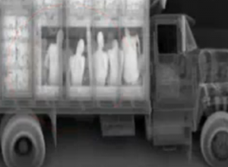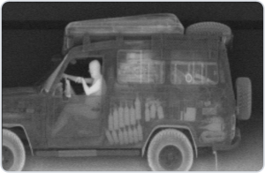
—————————————————————————————————————————————
In 2011 VIPR Conducted 9300 Random, Unconstitutional Checkpoints, Not One Terrorist
—————————————————————————————————————————————
Apprehended http://beforeitsnews.com/scandals/2013/02/in-2011-vipr-conducted-9300-random-unconstitutional-checkpoints-not-one-terrorist-apprehended-2430828.html (2-11-13)
—————————————————————————————————————————————
Intrusive new 'tattletale' app puts gun owners homes in crosshairs (7-12-13) http://www.bizpacreview.com/2013/07/12/intrusive-new-tattletale-app-puts-gun-owners-homes-in-crosshairs-79535
—————————————————————————————————————————————
Google has been secretly harvesting the passwords of all Wi-Fi devices everywhere http://www.naturalnews.com/042267_Google_harvesting_passwords_Wi-Fi_devices.html (9-29-13)
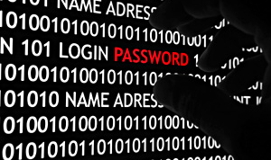

—————————————————————————————————————————————
License plate scanners collecting data on millions of U.S. drivers: ACLU report http://www.reuters.com/article/2013/07/17/us-usa-privacy-licenses-idUSBRE96G18620130717 (7-7-13)
—————————————————————————————————————————————

NSA's Utah Spy Supercenter Crippled By Power Surges
http://www.zerohedge.com/news/2013-10-08/nsas-utah-spy-supercenter-crippled-power-surges (10-8-13)
—————————————————————————————————————————————
Scientists seek to collect a 'blood database' of all U.S. newborns for 'research' purposes http://www.naturalnews.com/041248_newborns_blood_database_government.html (7-18-13)
—————————————————————————————————————————————
Researchers Develop X-Ray Vision with Wi-Fi http://www.fourwinds10.net/siterun_data/science_technology/new_technologies_and_inventions/news.php?q=1372869341 (7-1-13)

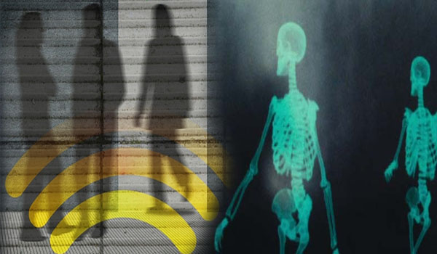
—————————————————————————————————————————————
New program plans to mandate electronic updateable license plates that track your every move
http://www.naturalnews.com/041001_license_plates_personal_privacy_surveillance_tracking.html (6-29-13)
—————————————————————————————————————————————
New TSA PreCheck program designed to gather fingerprints on millions of Americans
http://www.naturalnews.com/041352_TSA_airport_security_fingerprints.html (7-26-13)
—————————————————————————————————————————————Federal consumer 'protection' bureau caught data-mining the private financial records of millions of Americans (9-17-13)
http://www.naturalnews.com/042082_data-mining_private_financial_records_consumer_protection_bureau.html

—————————————————————————————————————————————
Gov't Bureau 'Creating a Google Earth on Every Financial Transaction,' Senator Warns
http://www.cnsnews.com/mrctv-blog/craig-bannister/govt-bureau-creating-google-earth-every-financial-transaction-senator (7-16-13)
—————————————————————————————————————————————
Pentagon Software Stores and Transcribes Thousands of Phone Calls [Into Text] at Once
http://www.storyleak.com/pentagon-software-stores-and-transcribes-thousands-of-phone-calls-at-once/ (7-20-13)
—————————————————————————————————————————————
Surprise! TSA Is Searching Your Car, Subway, Ferry, Bus AND Plane
http://www.motherjones.com/mojo/2011/06/tsa-swarms-8000-bus-stations-public-transit-systems-yearly (6-20-11)
—————————————————————————————————————————————
X-Ray Trucks Can See Inside Your Vehicle: Feel Like Somebodys Watching You? They Are
http://autos.aol.com/article/x-ray-truck/ (11-8-10)

American Science & Engineering X-Ray Truck. ASE©
—————————————————————————————————————————————
Valet parked cars searched under TSA regulations
http://www.fourwinds10.net/siterun_data/environment/travel/news.php?q=1374588790 (7-19-13)
The REAL X-Ray spex: New 'terahertz' scanner lets mobile phones see through walls - and through clothes
http://www.dailymail.co.uk/sciencetech/article-2131932/The-REAL-X-Ray-spex--new-terahertz-scanner-lets-mobile-phones-walls.html (4-10-12)
—————————————————————————————————————————————
Immigration reform hiding a plan requiring biometric national ID card for all US workers
http://www.naturalnews.com/041023_immigration_reform_biometrics_national_ID_card.html (7-1-13)

—————————————————————————————————————————————
NSA data bank hit by mystery power surges
http://www.fourwinds10.net/siterun_data/health/safety/news.php?q=1381511337 (10-10-13)
—————————————————————————————————————————————
Is the IRS the NSA? Tax agency buying up covert cameras to be hidden in plants and clock radios
http://www.naturalnews.com/040894_IRS_hidden_cameras_surveillance_equipment.html (6-22-13)
—————————————————————————————————————————————
New NSA Leaks Show How US Is Bugging Its European Allies
http://www.theguardian.com/world/2013/jun/30/nsa-leaks-us-bugging-european-allies (6-30-13)

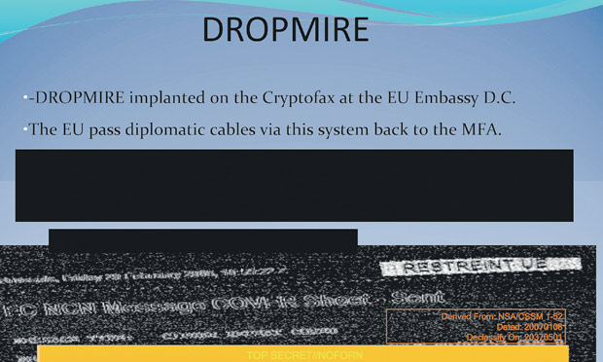
—————————————————————————————————————————————
Local supermarkets use NSA-stype spying on their own customers
http://www.naturalnews.com/042288_NSA_spying_local_supermarkets_customers.html (10-1-13)
—————————————————————————————————————————————
Grocery loyalty card purchases surveilled by insurance companies to raise rates and deny claims
http://www.naturalnews.com/039329_grocery_store_loyalty_cards_health_insurance.html (3-3-13)
—————————————————————————————————————————————
Orwellian Nightmare: Data-mining Your Kids
http://www.thenewamerican.com/culture/education/item/16193-orwellian-nightmare-data-mining-your-kids (8-8-13)
—————————————————————————————————————————————
How Google, Facebook, Skype, Yahoo and AOL are all blatantly lying to their own users in denying NSA spy grid scheme
http://www.naturalnews.com/z040692_NSA_spying_tech_companies_FISA.html (6-8-13)
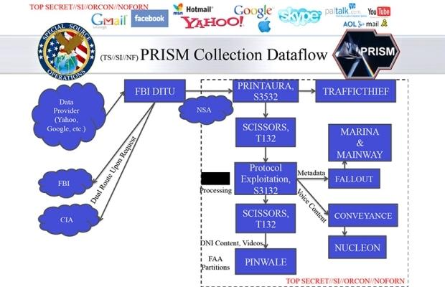
—————————————————————————————————————————————
Spy vs. Spy: Feds now want reports from retailers
http://www.wnd.com/2013/07/spy-vs-spy-feds-now-want-reports-from-retailers/ 7-11-13)
—————————————————————————————————————————————
NSA can spy on offline computer wirelessly, says security expert (12-20-13)
http://www.cbsnews.com/news/nsa-can-spy-on-offline-computers-wirelessly-expert-jacob-applebaum-says/
—————————————————————————————————————————————
U.S. court renews surveillance program exposed by Snowden
http://www.reuters.com/article/2013/07/19/us-usa-security-fisa-idUSBRE96I0WL20130719 (7-19-13)
—————————————————————————————————————————————
New Xbox Can See Through Your Clothes Like TSA Scanners
http://www.fourwinds10.net/siterun_data/media/internet/news.php?q=1385144976 (11-22-13)

—————————————————————————————————————————————
New Utah NSA center requires 1.7M gallon of water daily to operate
http://www.ksl.com/index.php?sid=25978926&nid=481 (7-12-13)
—————————————————————————————————————————————
Google plans on implanting chip in your brain (7-22-13)
http://www.fourwinds10.net/siterun_data/science_technology/new_technologies_and_inventions/news.php?q=1374679557
—————————————————————————————————————————————
Made-in-China kitchen appliances found to contain hidden Wi-Fi circuitry that installs malware on your home network
http://www.naturalnews.com/042786_Chinese_products_kitchen_appliances_spyware.html (11-5-14)

—————————————————————————————————————————————
NSA infiltrates links to Yahoo, Google data centers worldwide, Snowden documents say
http://www.washingtonpost.com/world/national-security/nsa-infiltrates-links-to-yahoo-google-data-centers-worldwide-snowden-documents-say/2013/10/30/e51d661e-4166-11e3-8b74-d89d714ca4dd_story.html (10-30-13)
—————————————————————————————————————————————
Healthcare.gov exposed as data-gathering honey pot to shamelessly harvest private consumer data and turn it over to the NSA
http://www.naturalnews.com/042664_Healthcaregov_NSA_data_mining_fake_front-end.html (10-25-13)
—————————————————————————————————————————————

Privacy Fears Grow as Cities Increase Surveillance
http://www.nytimes.com/2013/10/14/technology/privacy-fears-as-surveillance-grows-in-cities.html?pagewanted=all&_r=0 (10-13-13)
—————————————————————————————————————————————
Main Core: A List Of Millions Of Americans That Will Be Subject To Detention During Martial Law
http://www.rightsidenews.com/2013061132689/us/homeland-security/main-core-a-list-of-millions-of-americans-that-will-be-subject-to-detention-during-martial-law.html (6-11-13)
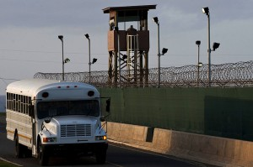
—————————————————————————————————————————————
T.S.A's armed VIPR squads conducting random sweeps at sporting events, music festivals, and train depots; says the warrantless "adminstrative" searches are exempt from probable cause
http://refreshingnews99.blogspot.in/2013/08/tsas-armed-vipr-squads-conducting.html (8-6-13)
—————————————————————————————————————————————
Armed TSA teams now roam in public, conduct "suspicionless searches" on demand
http://www.thedailysheeple.com/armed-tsa-teams-now-roam-in-public-conduct-suspicionless-searches-on-demand_082013 (8-14-13)
—————————————————————————————————————————————
NSA Prism program taps in to user data of Apple, Google and others
http://www.theguardian.com/world/2013/jun/06/us-tech-giants-nsa-data (6-6-13)
—————————————————————————————————————————————
Does the NSA Tap That? What We Still Don't Know About the Agency's Internet Surveillance
http://www.propublica.org/article/what-we-still-dont-know-about-the-nsa-secret-internet-tapping (7-22-13)
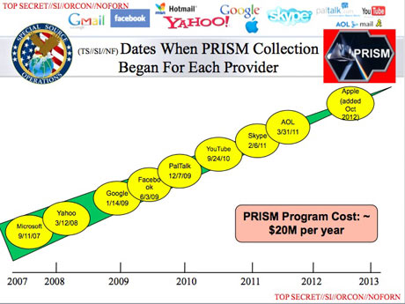
—————————————————————————————————————————————
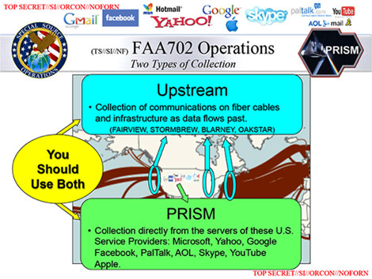
—————————————————————————————————————————————
Obama orders federal workers to spy on each other
http://www.naturalnews.com/z041209_Obama_federal_workers_spying.html (7-16-13)
—————————————————————————————————————————————
NSA Broke Privacy Rules Thousands of Times Per Year
http://www.washingtonpost.com/world/national-security/nsa-broke-privacy-rules-thousands-of-times-per-year-audit-finds/2013/08/15/3310e554-05ca-11e3-a07f-49ddc7417125_story.html (8-16-14)
—————————————————————————————————————————————
Your car's location is being routinely tracked by the government as you drive
www.naturalnews.com/z041466_license_plate_scanners_surveillance_state_police.html (8-3-13)
—————————————————————————————————————————————
NSA pays tech companies millions to engineer backdoors into encryption protocols
http://www.naturalnews.com/042038_NSA_tech_companies_encryption_protocols.html (9-13-13)

—————————————————————————————————————————————
NSA now admits spying on 75% of U.S. Internet traffic: Emails, texts, voice calls
http://www.naturalnews.com/041837_NSA_spying_United_States_Internet_traffic.html (8-30-13)
—————————————————————————————————————————————
LEAKED:
German Government Warns Key Entities Not To Use Windows 8 - Over Links To The NSA
http://www.businessinsider.com/leaked-german-government-warns-key-entities-not-to-use-windows-8--links-the-nsa-2013-8 (8-27-13)
—————————————————————————————————————————————
Government agencies at all levels selling personal data to marketers
http://www.naturalnews.com/041880_government_agencies_personal_data_marketers.html (9-1-13)
—————————————————————————————————————————————
Join the movement to end DRM - Digital Rights Management
http://www.naturalnews.com/041870_DRM_Digital_Rights_intellectual_property.html (9-1-13)

—————————————————————————————————————————————
Revealed: America's $53 billion spying budget
http://www.fourwinds10.net/siterun_data/government/homeland_security_patriot_act_fema/news.php?q=1378398093 (8-30-13)
—————————————————————————————————————————————
NSA surveillance program violates the constitution, ACLU says
http://www.theguardian.com/world/2013/aug/27/nsa-surveillance-program-illegal-aclu-lawsuit (8-27-13)
—————————————————————————————————————————————
Dianne Feinstein trying to eliminate protections for alternative media with amended 'Free Flow of Information Act' (9-14-13) http://www.naturalnews.com/042061_Free_Flow_of_Information_Act_alternative_media_censorship.html
Your supermarket is spying on you - and it will cost you money
http://www.telegraph.co.uk/finance/personalfinance/household-bills/10119302/Your-supermarket-is-spying-on-you-and-it-will-cost-you-money.html (6-14-13)

So-called "loyalty cards" might as well have been called "information cards"
Photo: Bloomberg
Google Reads Your Email Before You Do
http://www.fourwinds10.net/siterun_data/business/corporate_fraud/news.php?q=1410298337 (9-9-15)
—————————————————————————————————————————————
Scientists Build First Nanotube Computer
http://online.wsj.com/articles/SB10001424052702304795804579097201829598522 (9-25-13)
—————————————————————————————————————————————
RIFD Microchips to be Embedded in Breast Implants
http://www.infowars.com/rfid-microchips-to-be-embedded-in-breast-implants/ (10-18-13)
—————————————————————————————————————————————
Report: IBM developing computer system that thinks like a human (8-16-13)
http://www.fourwinds10.net/siterun_data/science_technology/computers_and_internet/news.php?q=1376662643

—————————————————————————————————————————————
Facebook has been secretly compiling 'shadow profiles' of all users
http://www.naturalnews.com/041040_Facebook_shadow_profiles_internet_privacy.html (7-2-13)
—————————————————————————————————————————————
Latest Info On The Microwave Vertical Array ELF Towers Being Erected Countrywide
http://www.fourwinds10.net/siterun_data/government/weapons/news.php?q=1416422510 (11-18-14)
—————————————————————————————————————————————
Confirmed: NSA's surveillance of mobile phones specifically targeted Americans
http://www.naturalnews.com/040854_NSA_spying_government_surveillance_mobile_phones.html (6-19-13)
—————————————————————————————————————————————
ATF To Monitor Gun Owners With Drones: Attorney General Confirms AFT To Buy Fleet Of Domestic Drones
http://www.fourwinds10.net/siterun_data/government/weapons/news.php?q=1397577069 (4-15-14)

—————————————————————————————————————————————
Fusion Center Locations Revealed
http://publicintelligence.net/fusion-center-locations-revealed/ (2-16-11)
—————————————————————————————————————————————
Report: Postal Service uses "spying" programs similar to NSA (7-3-13)
http://www.cbsnews.com/8301-201_162-57592319/report-postsal-service-uses-spying-programs-similar-to-nsa/
—————————————————————————————————————————————
JW Obtains Records Detailing Obama Administration's Warrantless Collection of Citizens' Personal Financial Data
https://www.judicialwatch.org/press-room/press-releases/jw-obtains-records-detailing-obama-administrations-warrantless-collection-of-citizens-personal-financial-data/ (6-27-13)
—————————————————————————————————————————————
Executive Order Accelerates Mandatory HIV Testing for All CItizens (7-16-13)
http://www.activistpost.com/2013/07/executive-order-accelerates-mandatory.html

—————————————————————————————————————————————
Snowden Interview: NSA and the Germans 'In Bed Together'
http://www.spiegel.de/international/world/edward-snowden-accuses-germany-of-aiding-nsa-in-spying-efforts-a-909847.html (7-7-13)
—————————————————————————————————————————————
New Obamacare ruling requires government agencies to share you personal health details
http://www.naturalnews.com/040958_Obamacare_medical_privacy_personal_information.html (6-26-13)
—————————————————————————————————————————————
Supreme Court rules cops can collect your DNA if they arrest you
http://www.naturalnews.com/040998_DNA_samples_warrantless_searches_Fourth_Amendment.html (6-29-13)
—————————————————————————————————————————————
DHS To roll out disease outbreak surveillance grid to spy on health of Americans
http://www.naturalnews.com/042043_DHS_surveillance_grid_disease_outbreak.html (9-13-13)


Government is also spying on your prescription drug use
http://www.naturalnews.com/041042_prescription_drugs_government_surveillance_HIPPA.html (7-2-13)
—————————————————————————————————————————————
ACLU says NSA spy program violates the U.S. Constitution
http://naturalsolutionsradio.com/blog/avgd123/aclu-says-nsa-spy-program-violates-us-constitution (9-10-13)
—————————————————————————————————————————————
America No Longer Has A Functioning Judicial System
http://www.globalresearch.ca/america-no-longer-has-a-functioning-judicial-system/5343478 (7-22-13)
—————————————————————————————————————————————

Wi-Fi Trashcans Now Silently Tracking Your Smartphone Data
http://www.storyleak.com/wi-fi-trashcans-tracking-your-smartphone-data/ (8-12-13)

—————————————————————————————————————————————
Snowden Files: NSA Holds Keys to Most Web Encryption
http://www.fourwinds10.net/siterun_data/media/internet/news.php?q=1378567533 (9-6-13)
—————————————————————————————————————————————
27 Edward Snowden Quotes About U.S. Government Spying That Should Send A Chill Up Your Spine
http://www.zerohedge.com/news/2013-06-11/27-edward-snowden-quotes-about-us-government-spying-should-send-chill-your-spine (6-11-13)
—————————————————————————————————————————————
U.S. Postal Service Logging All Mail For Law Enforcement
http://www.nytimes.com/2013/07/04/us/monitoring-of-snail-mail.html?pagewanted=all (7-3-13-)
—————————————————————————————————————————————
Obama Awarding Armored Tanks In Prepartion of Police State
http://www.fourwinds10.net/siterun_data/government/weapons/news.php?q=1376664461 (8-13-13)

—————————————————————————————————————————————
Government Spies Are Forcing Privacy Email Services To Shut Down Because They Can't Spy On Emails
http://www.infowars.com/government-spies-are-forcing-privacy-email-services-to-shut-down-because-they-cant-spy-on-emails/ (12-12-13)
—————————————————————————————————————————————
NSA Funds New "Top Secret" $60 Million Dollar Data Lab
http://www.infowars.com/nsa-funds-new-top-secret-60-million-dollar-data-lab/ (8-16-13)
—————————————————————————————————————————————
32 Privacy Destroying Technologies That Are Systematically Tranforming America Into A Giant Prison
http://www.activistpost.com/2013/11/32-privacy-destroying-technologies-that.html (11-27-13)
—————————————————————————————————————————————
Pentagon's new massive expansion of 'cyber-security' unit is about everything except defense
http://www.theguardian.com/commentisfree/2013/jan/28/pentagon-cyber-security-expansion-stuxnet (1-28-13)

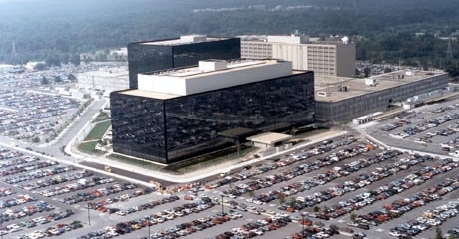

The National Security Agency (NSA) headquarters in Fort Meade, Maryland. Among other forms of intelligence-gathering, the NSA secretly collects the phone records of millions of Americans, using data provided by telecom firms AT&T, Verizon and BellSouth. Photograph: NSA/Getty Images
—————————————————————————————————————————————
A Statement By Edward Snowden At Moscow Airport
http://www.fourwinds10.net/siterun_data/peace_freedom/patriots_and_protesters/whistleblowers/news.php?q=1373895189 (7-12-13)
—————————————————————————————————————————————
Glenn Greenwald: Low-Level NSA Analysts Have 'Powerful and Invasive' Search Tool
http://abcnews.go.com/blogs/politics/2013/07/glenn-greenwald-low-level-nsa-analysts-have-powerful-and-invasive-search-tool/ (7-28-13)
—————————————————————————————————————————————
JW Obtains: Obama Admin Collecting Financial Data From Private Citizens Without Warrants
http://www.breitbart.com/InstaBlog/2013/06/27/Judicial-Watch-Obama-Regime-Collecting-Financial-Data-From-Private-Citizens-Without-Warrants (6-23-13)
—————————————————————————————————————————————
NSA collecting phone records of millions of Verizon customer daily
http://www.theguardian.com/world/2013/jun/06/nsa-phone-records-verizon-court-order (6-6-13)
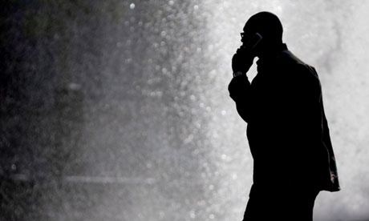
Under the terms of the order, the numbers of both parties on a call are handed over, as is location data and the
time and duration of all calls. Photograph: Matt Rourke/AP
—————————————————————————————————————————————
Spy Agencies Are Doing WHAT? "The Government is Spying on Essentially Everything We Do
http://globalresearch.ca/spy-agencies-are-doing-what-the-government-is-spying-on-essentially-everything-we-do/5351041 (9-23-13)
—————————————————————————————————————————————
NSA's Digital Dragnet on American . . . Gov't Trading Your Info with Mega Corps (6-13-13)
http://www.sagaciousnewsnetwork.com/nsas-digital-dragnet-on-americans-govt-trading-your-info-with-mega-corps/
—————————————————————————————————————————————
Obama White House Had Spying Limits Secretly Undone by Courts
http://www.gopusa.com/news/2013/09/09/obama-white-house-had-spying-limits-secretly-undone-by-court/ (9-9-13)


—————————————————————————————————————————————
Arizona Legislation Tells NSA "You're Not Welcome Here"
http://tenthamendmentcenter.com/2013/12/09/arizona-legislation-tells-nsa-youre-not-welcome-here/ (12-9-13)
—————————————————————————————————————————————
Facebook Says Technical Flaw Exposed 6 Million Users (6-21-13)
http://www.nytimes.com/2013/06/22/business/facebook-says-technical-flaw-exposed-6-million-users.html?_r=0
—————————————————————————————————————————————
Paramilitary government contractors now forcing drivers off the road, demanding DNA smples
http://www.naturalnews.com/043044_government_contractors_blood_samples_innocent_drivers.html (11-28-13)
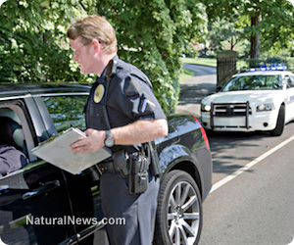
—————————————————————————————————————————————
Meet the Contractors Turning America's Police into a Paramilitary Force
http://www.alternet.org/print/meet-contractors-turning-americas-police-paramilitary-force (1-30-13)
—————————————————————————————————————————————
Israeli Data Spies Have Eyes Focused on U.S. Citizens
http://americanfreepress.net/?p=13798 (11-23-13)

—————————————————————————————————————————————
Airborne military craft to conduct facial recognition from the sky
http://www.naturalnews.com/046885_facial_recognition_surveillance_military_aircraft.html (9-16-14)
—————————————————————————————————————————————
Apple's time in the privacy spotlight.
http://www.privacywonk.net/2010/06/apples-time-in-the-privacy-spotlight.php (6-22-10)
—————————————————————————————————————————————
Cell Phone 'Towers' Are Not What We Were Lead To Believe
http://www.fourwinds10.net/siterun_data/environment/weather_and_climate/news.php?q=1369403144 (5-21-13)
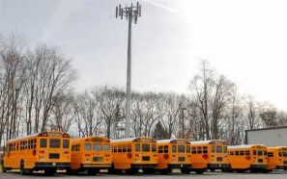
—————————————————————————————————————————————
Feds may force all new cars to broadcast their location, speed and direction to government authorities
http://www.naturalnews.com/043064_vehicle_black_boxes_federal_government_surveillance.html (11-27-13)

—————————————————————————————————————————————
Report: Social Connections of US citizens collected by NSA
http://dailycaller.com/2013/09/29/report-social-connections-of-u-s-citizens-collected-by-nsa/ (9-29-13)
—————————————————————————————————————————————
N.S.A. Gathers Data on Social Connections of U.S. Citizens (9-28-13)
http://www.nytimes.com/2013/09/29/us/nsa-examines-social-networks-of-us-citizens.html?pagewanted=all&_r=0
—————————————————————————————————————————————
TSA now maintaining secret 'watch list' of Americans to deny travel privileges
http://www.naturalnews.com/041063_tsa_watch_list_surveillance_state.html (7-5-13)

—————————————————————————————————————————————
DoD Training Manual: 'Extremist' Founding Fathers 'Would Not Be Welcome In Today's Military'
http://www.infowars.com/dod-training-manual-suggests-extremist-founding-fathers-would-not-be-welcome-in-todays-military/ (8-25-13)

—————————————————————————————————————————————
Every [smartphone] picture you take is secretly encoded with you GPS location
http://www.naturalnews.com/041068_metadata_internet_privacy_camera_phones.html (7-5-13)
—————————————————————————————————————————————
New TechCorp Wants to RFID Track Your Baby's Diapers
http://www.fourwinds10.net/siterun_data/science_technology/new_technologies_and_inventions/news.php?q=1374342079 (6-18-13)
—————————————————————————————————————————————
NSA Infects 50,000 Computer Systems Worldwide
http://www.veteranstoday.com/2013/11/26/nsa-infects-50000-computer-systems-worldwide/ (11-26-13)

—————————————————————————————————————————————
http://www.thesleuthjournal.com/nsa-infects-50000-computer-systems-worldwide/ . . .
How TRUE!
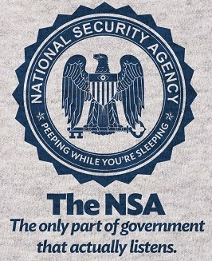
—————————————————————————————————————————————
DEA using 'terrorism' surveillance to entrap Americans
http://www.naturalnews.com/041516_surveillance_DEA_Americans.html (8-7-13)
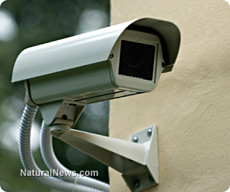
—————————————————————————————————————————————
NSA uses supercomputers to crack Web encryption, files show
http://www.usatoday.com/story/news/nation/2013/09/05/nsa-snowden-encryption-cracked/2772721/ (9-5-13)
—————————————————————————————————————————————
This June 6, 2013, photo shows the sign outside the National Security Agency campus at Fort Meade, Md. (Photo: Patrick Semansky, AP)
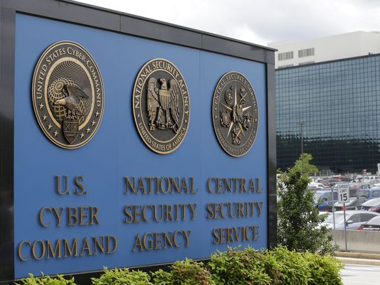

—————————————————————————————————————————————
A TREASURE TROVE of 84 photos covering the NSA's massive surveillance machinery. Here are a few of them:
—————————————————————————————————————————————
—————————————————————————————————————————————

—————————————————————————————————————————————


—————————————————————————————————————————————
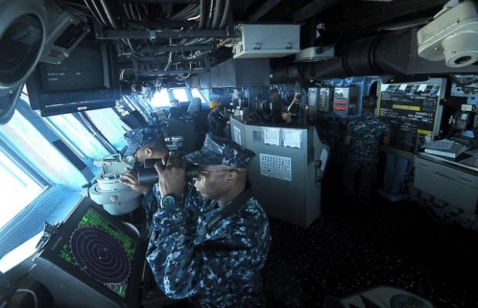
—————————————————————————————————————————————

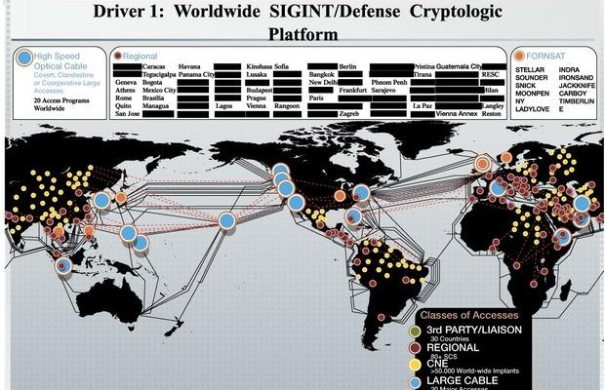
—————————————————————————————————————————————
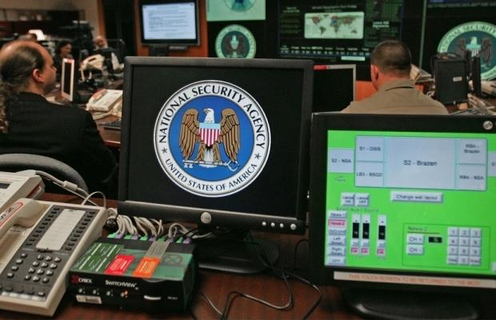
—————————————————————————————————————————————
Whistleblower: Google Chrome Can Listen To Your Conversations
http://www.infowars.com/whistleblower-google-chrome-can-listen-to-your-conversations/ (1-23-14)
—————————————————————————————————————————————
New Gun Lets Police Shoot And Capture Your DNA
http://www.fourwinds10.net/siterun_data/government/weapons/news.php?q=1381175878 (9-30-13)
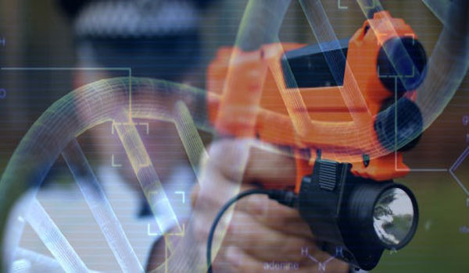—————————————————————————————————————————————
Former judge admits flaws in secret FISA court
http://www.cbsnews.com/news/former-judge-admits-flaws-with-secret-fisa-court/ (7-9-13)
—————————————————————————————————————————————
Obama's Plan to Crack Down on Whistleblowers Leaked
http://truth-out.org/news/item/17500-obamas-plan-to-crackdown-on-whistleblowers-leaked (7-11-13)
—————————————————————————————————————————————
Is Your Television Actually 'Watching' You?
http://www.fourwinds10.net/siterun_data/media/television/news.php?q=1375892435 (8-7-13)

—————————————————————————————————————————————
http://indiandefence.com/threads/nsa-surveillance-discussions.41493/page-3

—————————————————————————————————————————————
What's The Purpose For All The Surveillance? . . . That Is THE Question . . .
—————————————————————————————————————————————
IF you can't answer that question by now, then you haven't done your homework. May you continue in your ignorance and oblivian . . . you'll deserve the future you get, because you did NOTHING to stop it.
—————————————————————————————————————————————
Prepare for WAR ~ Arm Yourself With Knowledge!
—————————————————————————————————————————————
You'll find plenty of 'ammo' at StopTheNorthAmericanUnion.com
—————————————————————————————————————————————
The EU and the NAU ~ Two Peas in a Pod! HERE
Treason Abounds ~ Gov't Cabal Plots North American Union HERE
TWO 'ACTS' OF TYRANNY ON THE SAME DAY! HERE
Using Bilingualism to Subvert America HERE
Illegal Alien Anarchy . . . Connecting the Dots! HERE
—————————————————————————————————————————————
If you are reading and sharing this information ~ you are part of the resistance!
—————————————————————————————————————————————
Daneen G. Peterson, Ph.D.
Researcher, Author and Founder
http://www.StopTheNorthAmericanUnion.com
email: Daneen@Peterson.name
—————————————————————————————————————————————
You can sign up for the FREE Newsletter here: http://www.stopthenorthamericanunion.com/Alerts.html
—————————————————————————————————————————————
FAIR USE NOTICE: This 'Newsletter' contains copyrighted material, the use of which may not always have been specifically authorized by the copyright owner. Such material is made available for educational purposes, and as such this constitutes 'fair use' of any such copyrighted material as provided for in section 107 of the US Copyright Act. In accordance with Title 17 U.S.C. Section 107, the material on this site is distributed without profit to those who have expressed a prior interest in receiving the included information for research and educational purposes.

